National College of Ireland

HDCSDEV_INT Higher Diploma in Science in Computing

Tansel Seray Aydınlı

23348381

Lkhagvadulam Boldbayar

23366141

Anand Enkhbold

24104710

ALT TRAVEL AGENCY

Eugene McLaughlin

**Table of Contents**

1. **Project Overview**  
   1.1. Introduction to ALT Travel Website  
   1.2. Purpose and Goals
2. **Design Process**  
   2.1. Research & Investigation  
   2.2. Requirements & Technical Approach  
   2.3. Design and Wireframe  
   2.3.1. Navigation and Footer Design  
   2.3.2. Wireframe and UI Animation
3. **Project Work**  
   3.1. Breakdown of Tasks  
   3.2. Individual Contributions  
   3.2.1. About Page Development  
   3.2.2. Anniversary Tour Page
4. **Development Process**  
   4.1. HTML, CSS, and JavaScript Implementation  
   4.1.1. Submenu Functionality  
   4.1.2. JavaScript Animations  
   4.2. Image Sliders and Client Reviews  
   4.3. Responsive Design
5. **Testing and Deployment**  
   5.1. Testing for Responsiveness and Functionality
6. **Conclusion**  
   6.1. Results, Achievements, and Team Contributions  
   6.2. Future Improvements
7. **References**

**1. Project Overview**

**1.1 Introduction to ALT Travelling Website**

ALT Travelling is a forward-thinking travel agency specializing in creating memorable travel experiences. Our mission is to provide a seamless platform for users to explore, plan, and book travel packages tailored to their needs. From solo tours to family vacations and anniversary getaways, ALT Travelling aims to cater to all travelers seeking curated experiences.

The website offers a range of services, including showcasing travel packages, providing detailed tour information, and facilitating easy communication with the agency through a dedicated "About Us" and "Contact Us" section. ALT Travelling emphasizes accessibility and an engaging user interface to ensure every traveler can effortlessly explore and book their dream trips.

**1.2 Purpose and Goals**

The ALT Travelling website was developed to transform traditional travel services into a dynamic online platform that improves customer engagement and expands the business. With a focus on showcasing tours with detailed information and vivid imagery, the website makes it easier for travelers to plan and purchase travel packages. By providing a robust online presence, the platform also enhances ALT Travelling's visibility and competitiveness in the travel industry.

**Goals:**

1. Present travel packages with high-quality visuals and comprehensive details to attract customers.
2. Develop a user-friendly interface that simplifies navigation and ensures a seamless booking experience.
3. Offer accessibility features, including an "About Us" page and contact options, to build trust and facilitate communication.
4. Increase online visibility through search engine optimization and responsive design to attract a wider audience.

### 2. Design Process

**2.1 Research and Investigation**

To create a user-centric and visually appealing website, the team conducted extensive research on existing travel websites. We analyzed features such as navigation structure, page layouts, color schemes, and user engagement strategies. Websites like “ <https://www.theultimatetravelcompany.co.uk>” inspired our focus on responsive design, vibrant visuals, and clear calls to action.

Our key findings:

* **Navigation:** Easy-to-use menus improve user engagement and minimize bounce rates.
* **Imagery:** High-quality, captivating images are essential for a travel website.
* **Responsiveness:** A seamless experience across devices is critical for today’s users.

**2.2 Requirements and Technical Approach**

The ALT Travelling website required the following features:

* **Functional Requirements:**
  + Showcase travel packages for solo, anniversary, and family tours.
  + An interactive contact form for inquiries.
  + A dedicated "About Us" page for trust-building.
* **Technical Requirements:**
  + Fully responsive design using Bootstrap.
  + JavaScript to enhance interactivity and validation.
  + Optimization for fast loading and SEO.

To meet these requirements, we employed HTML, CSS and JavaScript ensuring modern and efficient web development practices.

**2.3 Design and Wireframe**

The design process began with wireframing the key pages, ensuring an intuitive user flow and aesthetic consistency.

* **Navigation and Footer Design:**
  + The header includes ALT Travelling’s logo, navigation links (Home, Travel Packages, About Us, Contact Us), and a call-to-action button for bookings.
  + The footer features quick links, social media icons, and contact information.
* **Wireframe and UI Animation:** Wireframes were created for:
  + **Home Page**: Features a hero section with images, introductory text, and links to travel packages.
  + **Travel Packages(Solo-Anniversarry-Family) Pages**: A gallery-style display of travel options, each with descriptions and images.
  + **About Us Page**: Highlights the agency’s story, mission, and team.
  + **Contact Us Page**: Includes a form for inquiries .

**3. Project Work**

**3.1 Breakdown of Tasks**

The project was divided into specific tasks to ensure a structured and efficient workflow. Each team member was assigned responsibilities based on their strengths and interests. The main tasks included designing, developing, and testing the website, as well as incorporating user-friendly features and responsive elements.

**Task Breakdown:**

1. **Home Page**:
   * Creation of a visually appealing homepage with a hero image, introductory text, and navigation links.
   * Assigned to: Anand Enkhbold-24104710
2. **About Us Page**:
   * Crafting the agency's story, mission, and customer testimonials to build trust and engagement.
   * Assigned to: Tansel Seray Aydinli-23348381.
3. **Solo Tours Page**:
   * Development of a page showcasing solo travel packages with descriptions, itineraries, and pricing.
   * Assigned to: Anand Enkhbold-24104710
4. **Anniversary Tours Page**:
   * Creation of a page highlighting romantic getaway packages for anniversaries, complete with features like couple experiences and scenic recommendations.
   * Assigned to: Tansel Seray Aydinli-23348381.
5. **Family Tours Page**:
   * Design and implementation of a family-oriented page showcasing travel options for parents and children, with activities, itineraries, and pricing details.
   * Assigned to: Lkhagvadulam Boldbayar-23366141.
6. **Contact Us Page**:
   * Implementing a functional contact form and embedding a map for location details.
   * Assigned to: Lkhagvadulam Boldbayar-23366141.
7. **Responsive Design**:
   * Ensuring the website works seamlessly across all devices using Bootstrap and media queries.
   * Shared among all team members.
8. **JavaScript Features**:
   * Adding interactivity such as animations, form validation, and dynamic elements.
   * Shared among all team members.Each member have their own JavaScript.

**3.2 Individual Contributions**

1. **Anand Enkhbold (24104710):**
   * Designed and developed the **Home Page** and **Solo Tours Page**.
   * Focused on creating a responsive layout with engaging visuals.
   * Implemented JavaScript features for interactive buttons and animations.
2. **Tansel Seray Aydinli (23348381):**
   * Crafted the **About Us Page** and the **Anniversary Tours Page**.
   * Highlighted customer testimonials and romantic packages with scenic elements.
   * Developed JavaScript features for carousel and dynamic content.
3. **Lkhagvadulam Boldbayar (23366141):**
   * Designed the **Family Tours Page** and implemented the **Contact Us Page**.
   * Integrated a functional contact form with JavaScript validation.
   * Added a Google Maps feature to display the agency's location.

**4. Development Process**

**4.1 HTML, CSS, and JavaScript Implementation**

The ALT Travelling website was developed using the latest web development technologies to ensure functionality, aesthetics, and performance.

* **HTML**:
  + Structured the content across all pages, including text, images, and interactive forms.
  + Semantic elements like <header>, <footer>, and <section> were used for better accessibility and SEO.
* **CSS**:
  + Designed the visual layout of the website using an external stylesheet.
  + Applied styling for headers, footers, and buttons to ensure consistency across pages.
  + Used CSS animations for hover effects on navigation and interactive elements.
* **JavaScript**:
  + Added interactivity to forms, validating input fields such as names, emails, and tour preferences.
  + Implemented dynamic features like smooth scrolling and image sliders on the homepage.

**4.2 Frameworks and Tools**

* **Bootstrap**:
  + Utilized for responsive grid layouts and navigation components.
  + Ensured consistency across devices, including desktops, tablets, and mobile phones.
* **jQuery**:
  + Implemented for dynamic functionality like dropdown menus and animation effects.

**4.3 Image Sliders and Animations**

Interactive and visually appealing elements were added to enhance user engagement:

* **Image Sliders**: Used to showcase top destinations and tour highlights on the homepage and tours pages.
* **Animations**: Smooth transitions and hover effects were added to buttons and links for better user experience.

**4.4 Responsive Design**

To ensure a seamless experience across all devices:

* **Media Queries**: Adjusted layouts for different screen sizes, including mobile, tablet, and desktop views.
* **Bootstrap Grid System**: Ensured responsive column layouts for all pages.

**5. Testing and Deployment**

**5.1 Testing for Responsiveness and Functionality**

To ensure that the ALT Travelling website meets modern web standards and delivers a smooth user experience, rigorous testing was performed during development.

* **Responsiveness**:
  + Verified the website's appearance and usability across various screen sizes, including desktops, tablets, and mobile devices.
  + Used browser developer tools and tools like [Google Mobile-Friendly Test] to ensure a seamless experience on different devices.
  + Media queries were fine-tuned to adjust layouts, text sizes, and images for smaller screens.
* **Form Validation**:
  + Tested the contact form for proper validation using JavaScript.
  + Verified that all required fields, such as name, email, and message, cannot be submitted empty.
  + Ensured error messages were user-friendly and guided users to correct inputs.
* **Functionality**:
  + Checked all links, navigation menus, and buttons to confirm they work correctly.
  + Tested JavaScript features like image sliders and animations for proper behavior.
  + Ensured smooth scrolling and hover effects were functioning without delays or glitches.
* **Performance**:
  + Tested loading times using tools like Google PageSpeed Insights.
  + Optimized images to reduce loading times and enhance overall performance.
* **Browser Compatibility**:
  + Tested the website across multiple browsers, including Google Chrome, Mozilla Firefox, Microsoft Edge, and Safari, to ensure consistent functionality and appearance.

**6. Conclusion**

**6.1 Results, Achievements, and Team Contributions**

The ALT Travelling website successfully achieved its objectives of creating a user-friendly, visually appealing, and responsive platform for travelers. Each team member contributed effectively, ensuring that the project met the functional and aesthetic requirements.

**Key Achievements:**

1. Developed a responsive and engaging website featuring pages for Solo, Anniversary, and Family Tours.
2. Integrated interactive features such as image sliders, dynamic animations, and a fully functional contact form.
3. Optimized the website for faster loading and SEO, improving its visibility and usability.
4. Successfully tested the website across multiple devices and browsers, ensuring a consistent user experience.

**Team Contributions:** Each team member demonstrated commitment and collaboration throughout the project. Regular meetings and open communication ensured that challenges were addressed promptly and efficiently. The balanced division of tasks allowed each member to apply their strengths while contributing to the overall success of the project.

**6.2 Future Improvements**

While the website achieved its initial goals, there are opportunities for further enhancement:

1. **Payment Integration**: Adding an online payment system to enable direct booking on the platform.
2. **Dynamic Content**: Implementing a content management system (CMS) for easy updates to tours and packages.
3. **Chat Support**: Introducing a live chat feature to assist users with inquiries in real-time.
4. **Enhanced SEO**: Continuously improving SEO strategies to increase organic traffic and visibility.

The project provided a valuable learning experience in web design and development, showcasing the team’s ability to create a professional-grade website. Moving forward, these improvements will ensure ALT Travelling continues to meet evolving user expectations and market demands.

**1.Design**

**Inspiration from The Ultimate Travel Company Website**  
During the design process for my website, I researched various travel and tour agency websites to gather ideas and best practices. One of the websites that significantly inspired my work was [The Ultimate Travel Company](https://www.theultimatetravelcompany.co.uk/). Its responsive design, engaging layout, and functional features provided a valuable reference.

Specifically, I was impressed by:

* **Responsive Design:** The website's seamless adaptability to different devices and screen sizes ensures an optimal user experience.
* **Image-Based Layout:** The use of high-quality imagery paired with concise text overlays effectively captures user attention while conveying essential information.
* **Interactive Elements:** Features such as image sliders and hover effects on boxes enhance interactivity and visual appeal.
* **Structured Information Presentation:** The clear segmentation of information into easily digestible sections allows users to navigate the site effortlessly.

These elements served as inspiration for my own design approach, where I incorporated similar features to enhance usability, visual aesthetics, and engagement for users.

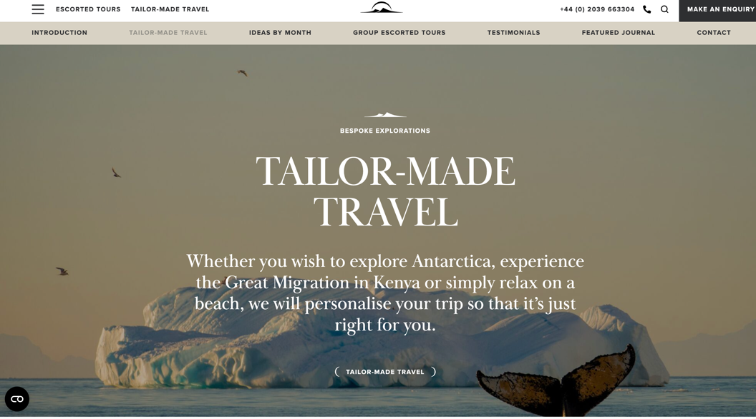

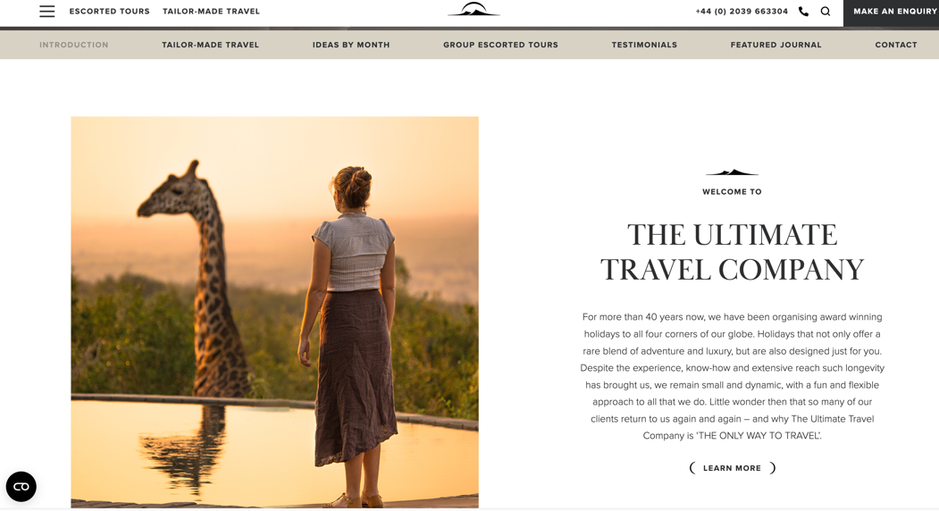

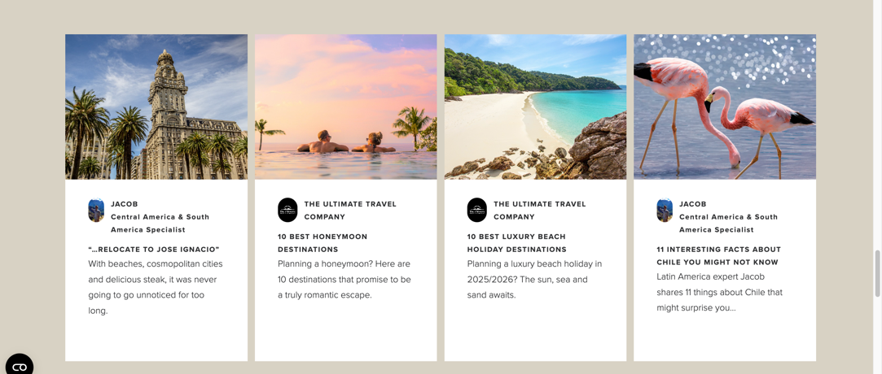

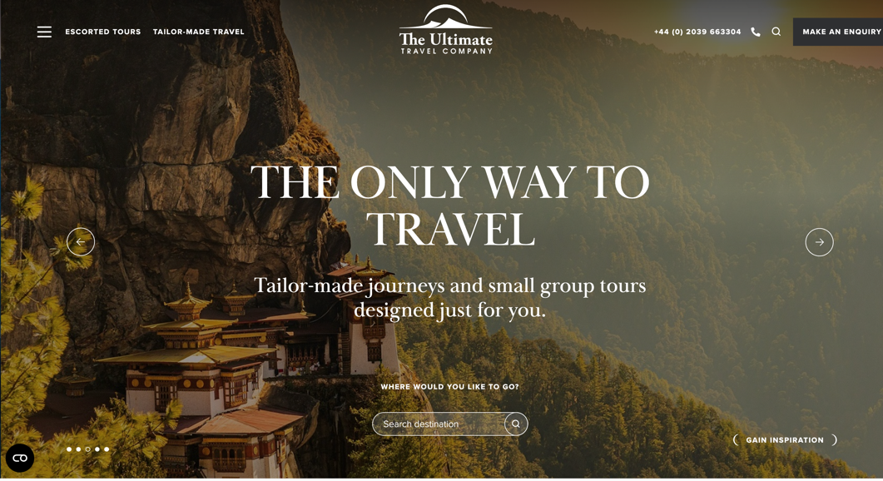

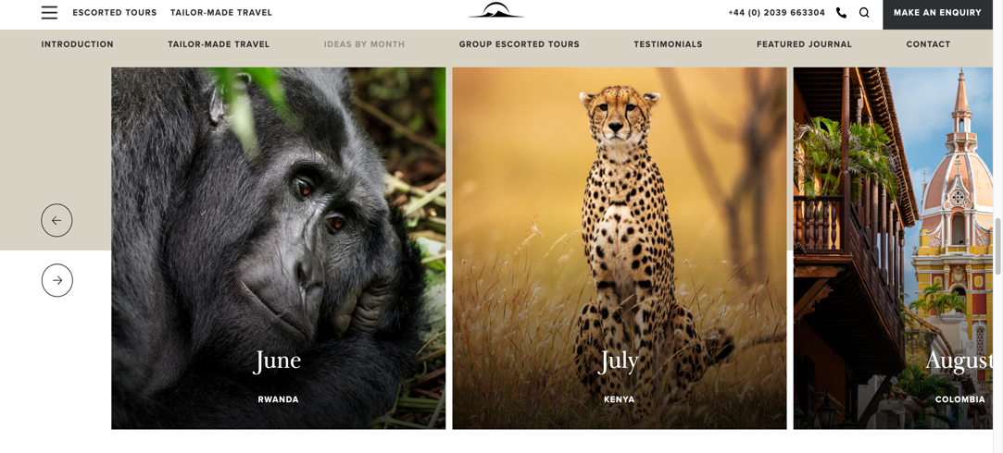

**2.Wireframe (About Us page,Anniversary Tour page / Tansel Seray Aydinli )**

About Us Page/ Created by Tansel Seray Aydinli

1-Our Story/Our Mission/Our Team 2- Our Services

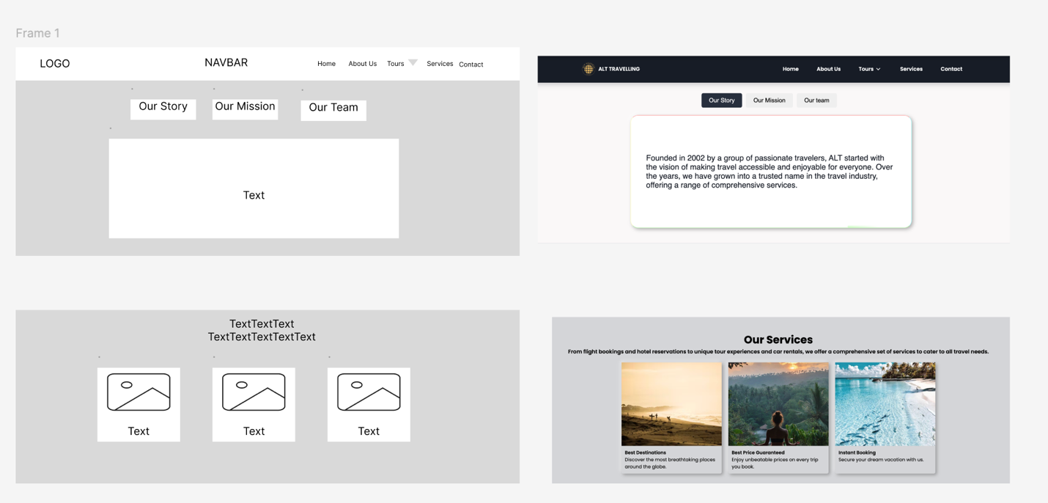

Tour Packages Part-

1-Solo Tours 2-Anniversary Tours 3-Family Tours

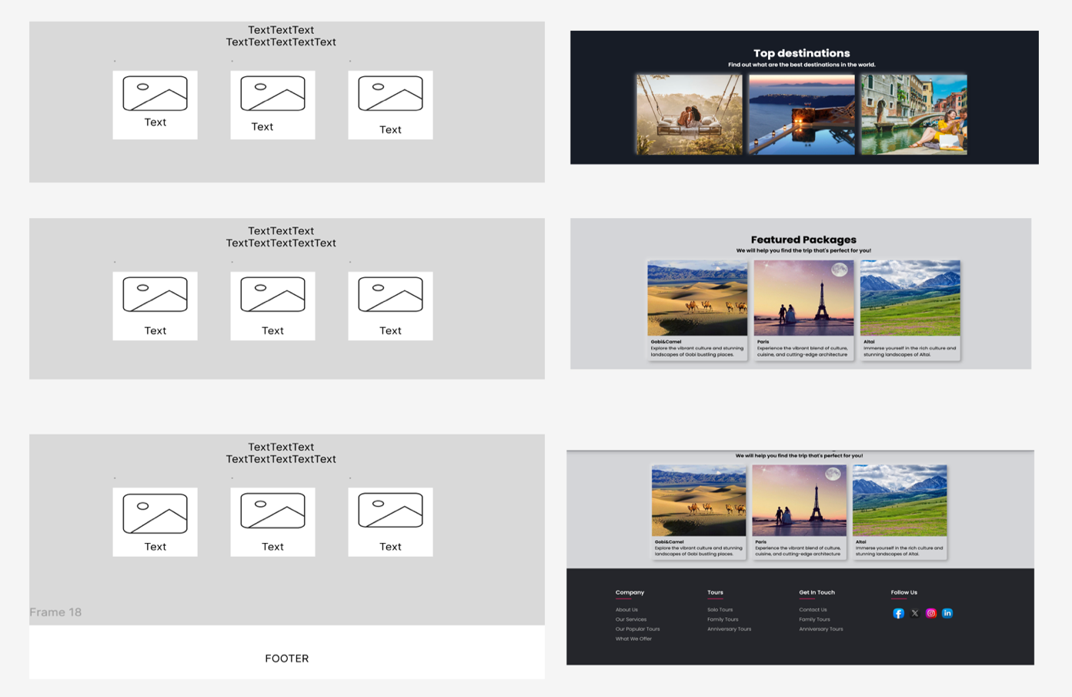

Anniversarry Tour page/ Created by Tansel Seray Aydinli

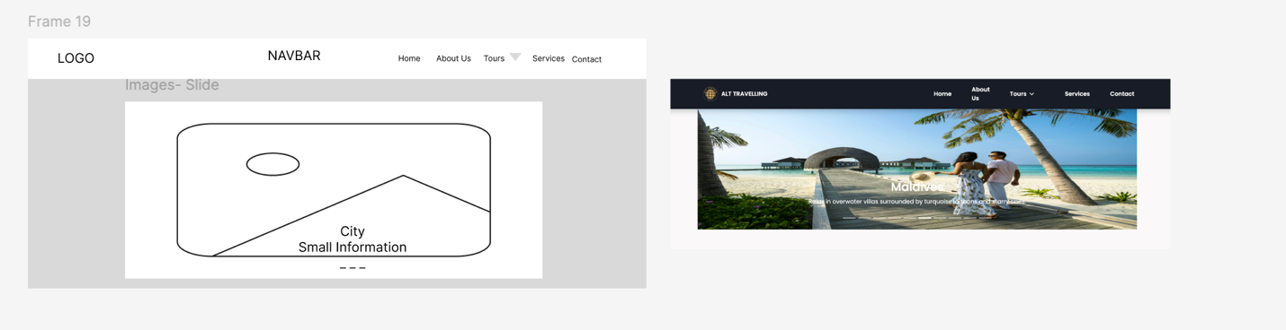

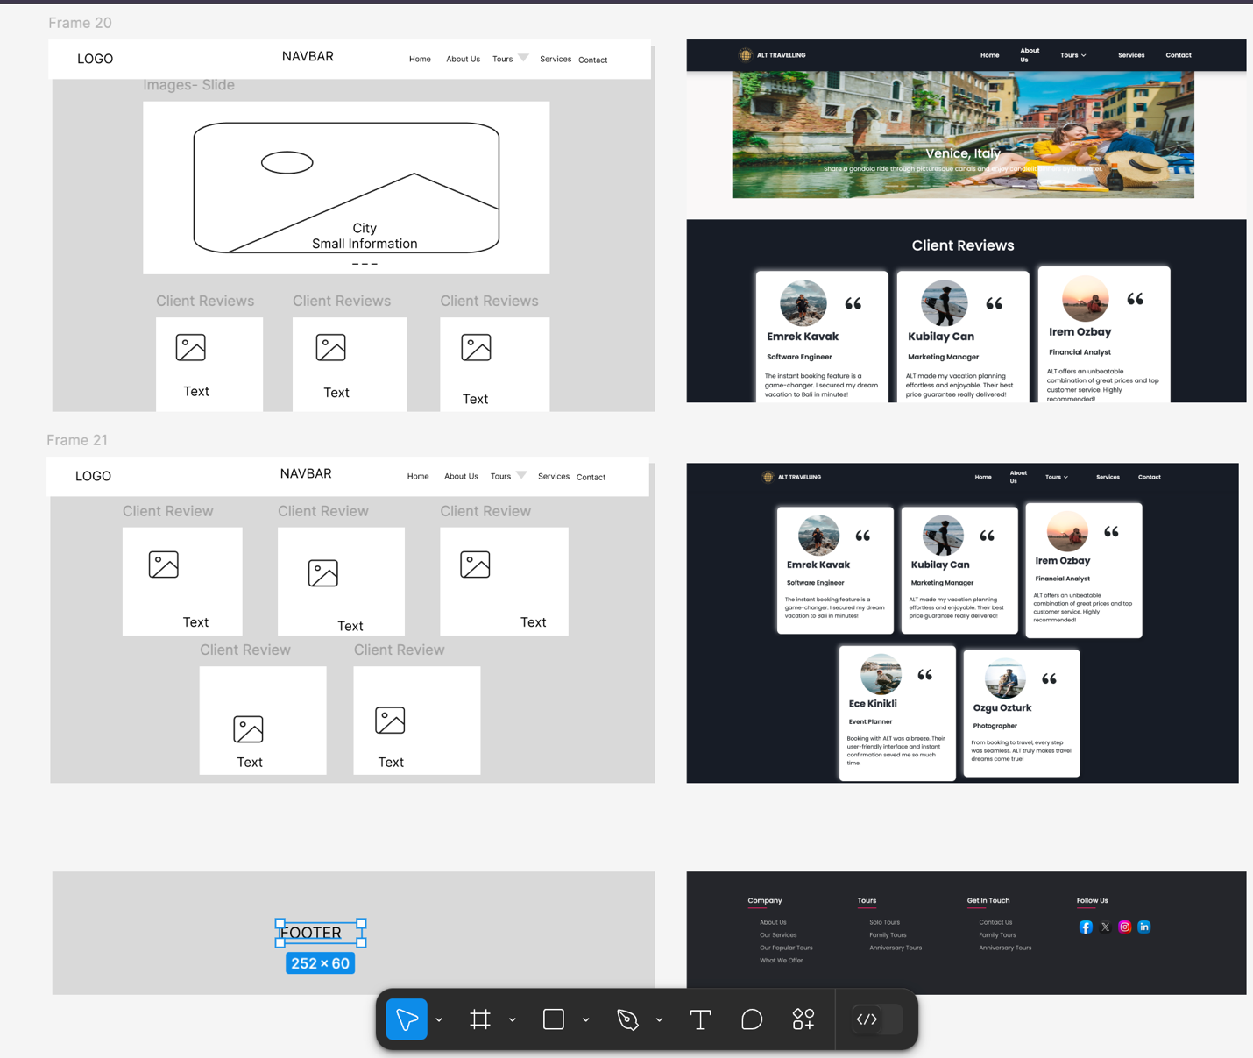

The ALT website which is a booking for travel website cuts across all the vacation types one can dream to have in a life time. From visting various historical sites and nature locations to great towns and cities, one only need to book for this from the comfort of their house.

In developing the website, we equally shared the task among a group of three members. I was tasked to develop the ***about*** page and the ***anniversary tour*** page. I employed the use of **html, css, and javascript** .

Also, I reused the navigation that we had developed in the group which was to be used across all pages together with the footer.

**About page**

The about page had four sections namely:

* Our story, Mission, and Our team

there is a sub menu where a person clicks to select a view of either; Our story, mission, or Our team. Use of javascript click function in displaying custome content and hiding others.

**Figure 1.**

* Our services

It displays the services offered from travelling and visting places to being directed on the best places. there was use of CSS in animating the images in this section. This brings an appealing nature of the website to the client.

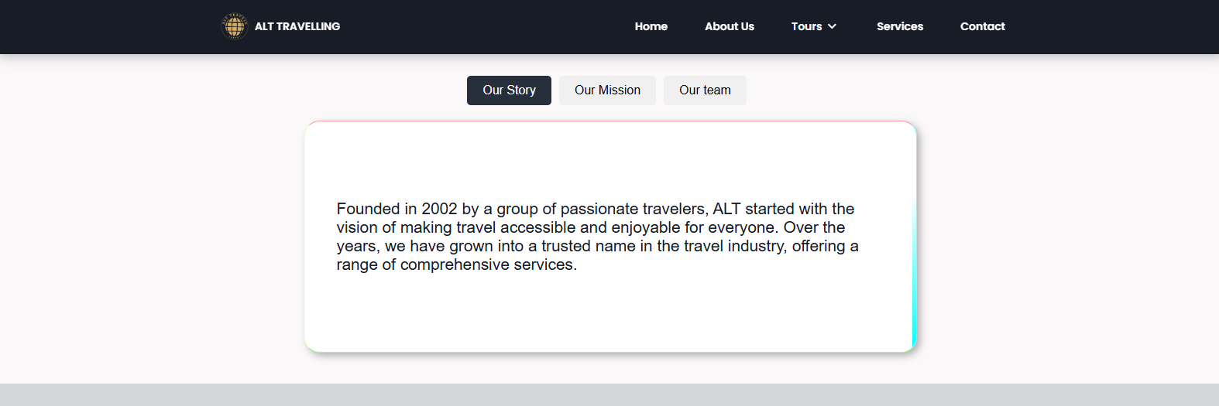

**Figure 1.**

**3. JAVASCRIPT:**

The javascript code for the submenu section is as bellow:

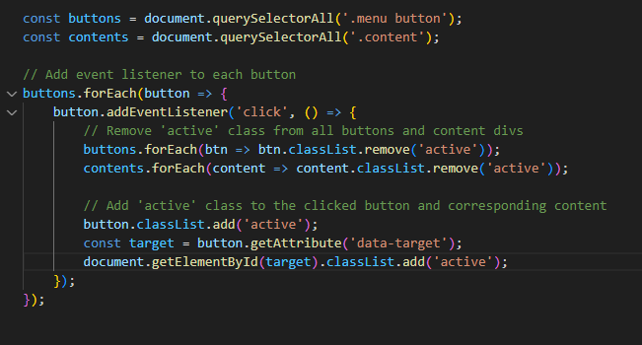

Elements with class name ***menua button*** and  ***content*** are seleced.

Using the eventlistener of onclick, the button cliked becomes active, thus fetching the content using the same corresponding to the content.

The **CSS**  userd brough an appealiang layout by utilizing the css animation of border.

* Top destinations

**JavaScript:** In the about page, tour packages sections, which include Solo Tours, Anniversary Tours and Family Tours. It uses javascript onlick triggers. When a user clicks on an images, they are redirects to the Solo Tours page, Anniversarry Tours page and Family Tours page .

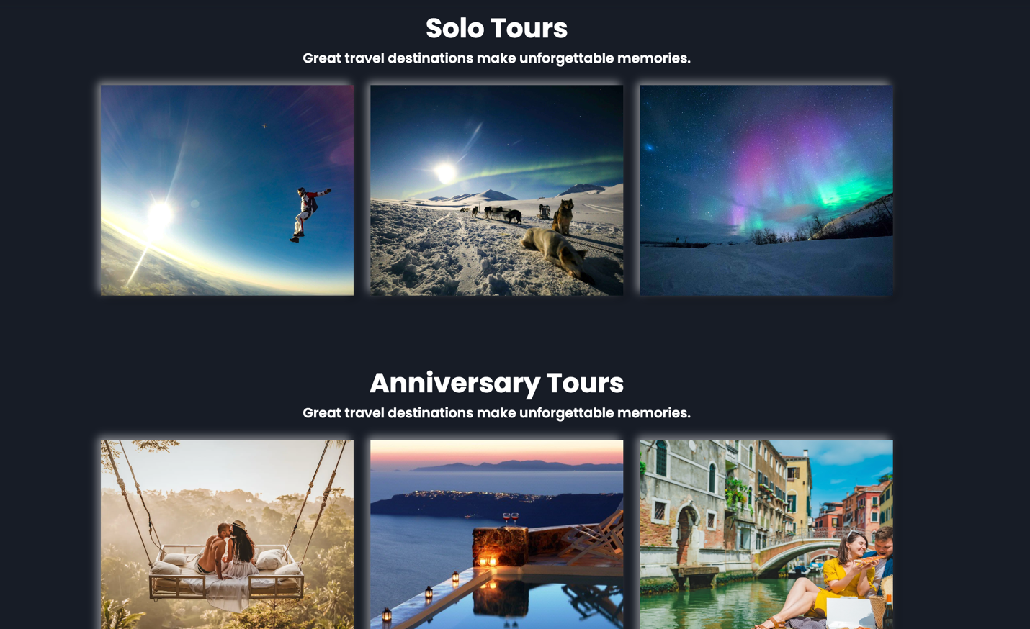

**Figure 2.**

**The Anniversary Tour Page**

This page had two sections:

* The images sliders

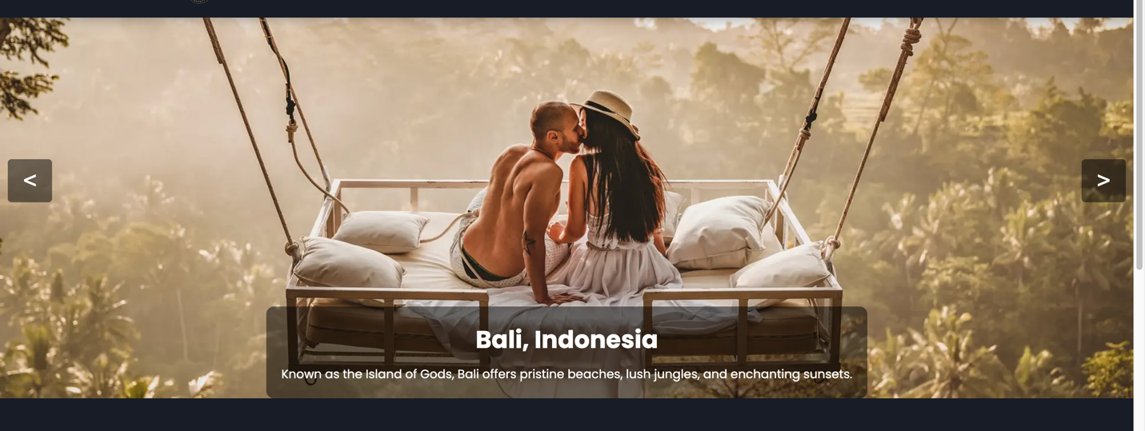

**Figure 3.**

* Client reviews: On hovering over the clients review, there is a scaling up and change of background color by use of js animation.

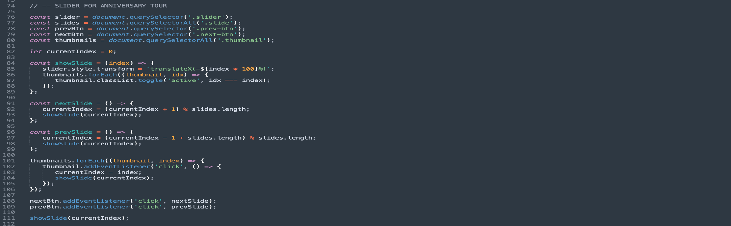

• **Purpose**: Adds a slider with navigation buttons and thumbnail support.

• **Key Features**:

* Slides transition horizontally with translateX CSS transformation.
* Navigation:
  + **Next/Previous Buttons**: Move the slider forwards or backwards cyclically.
  + **Thumbnails**: Allow direct navigation to specific slides.
* Highlights the active slide by toggling the active class on thumbnails.

• **Enhancements**:

* Smooth animations for transitions.
* Handles circular navigation (loops back to the first slide after the last).

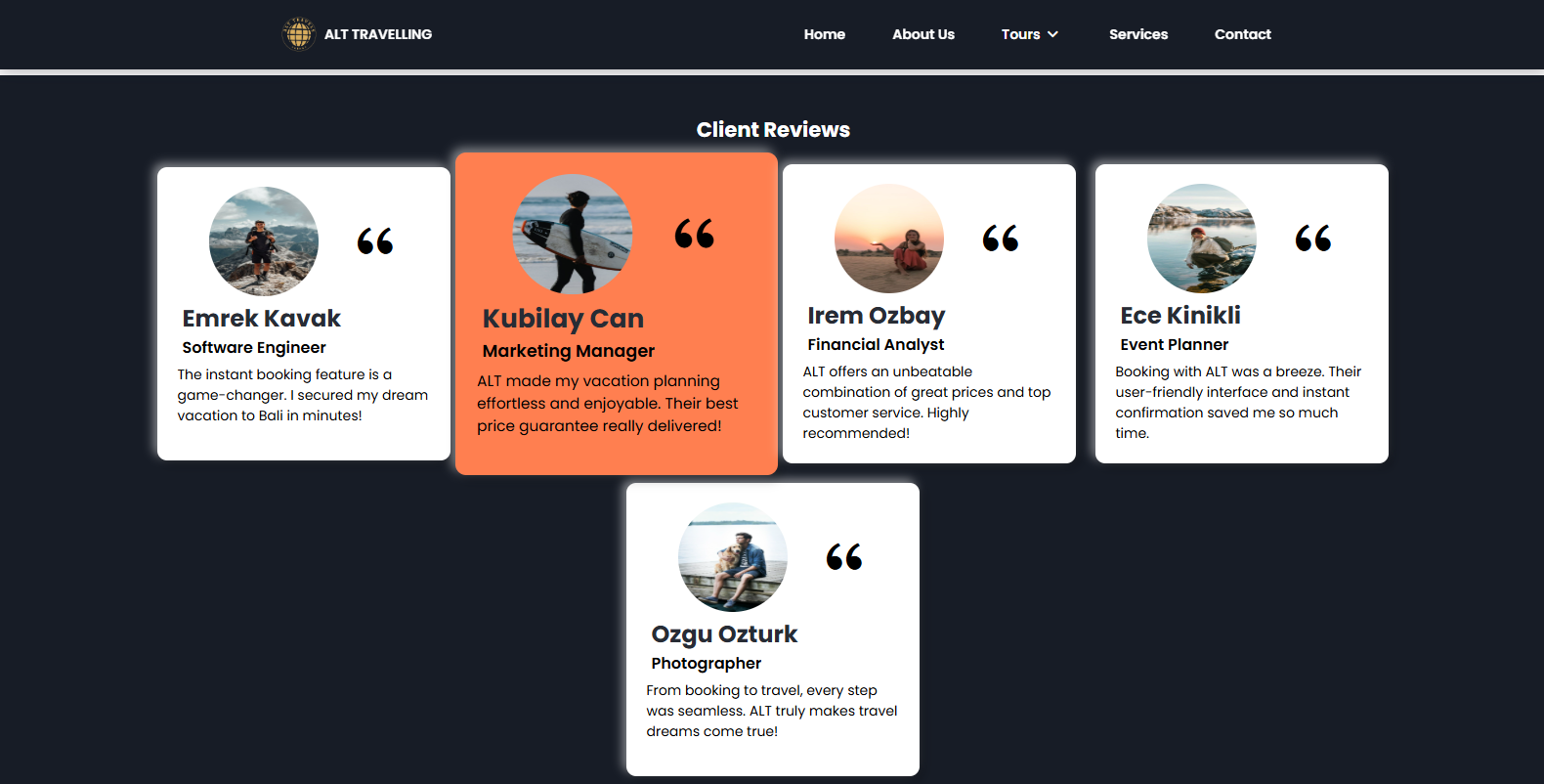

**Figure 4.**

**Interactive Review Boxes**

**Purpose**: Adds hover animations to review boxes.

**Key Features**:

Scales up (transform: scale(1.1)) and changes the background color to coral on hover.

Resets to original scale and background color on mouse out.

**The responsive pages using CSS**

To achieve responsive design, I used CSS media querry in designing the layout of the pages in different screen sizes.

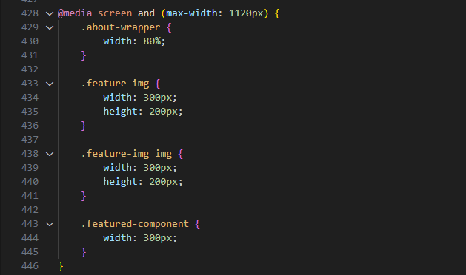

**4.Validation** (Created Tansel Seray Aydınlı 23348381 )

HTML Files: 1-about.html (7 errors)

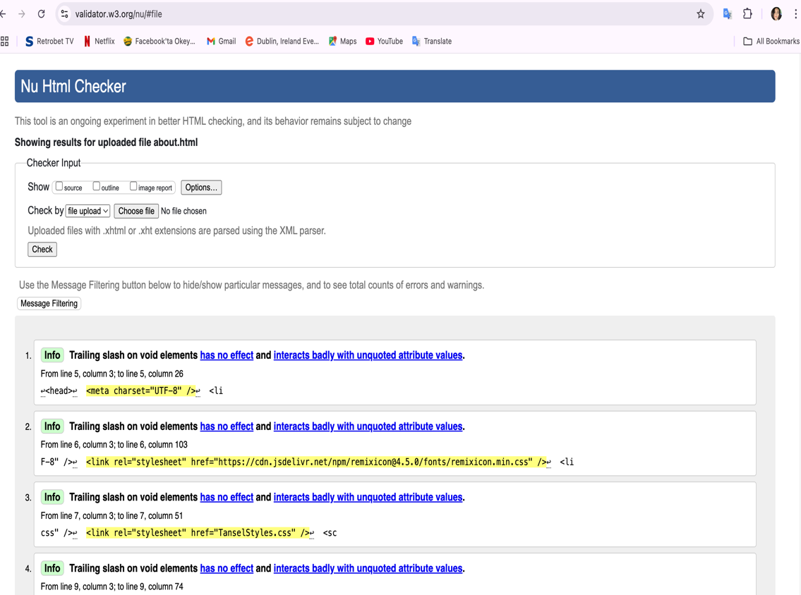

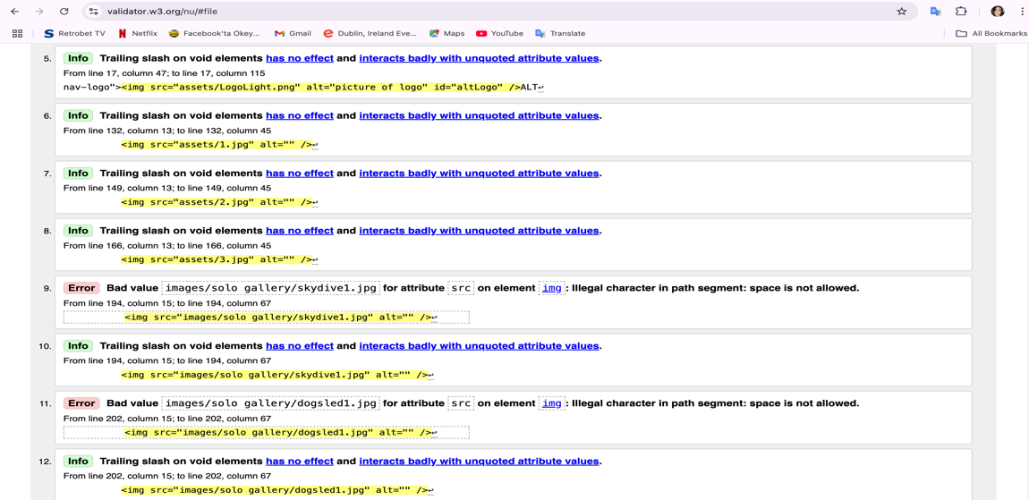

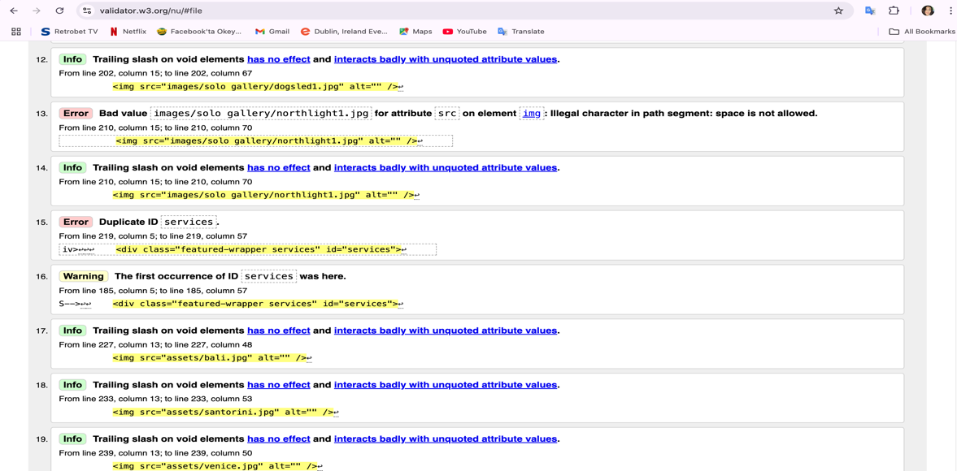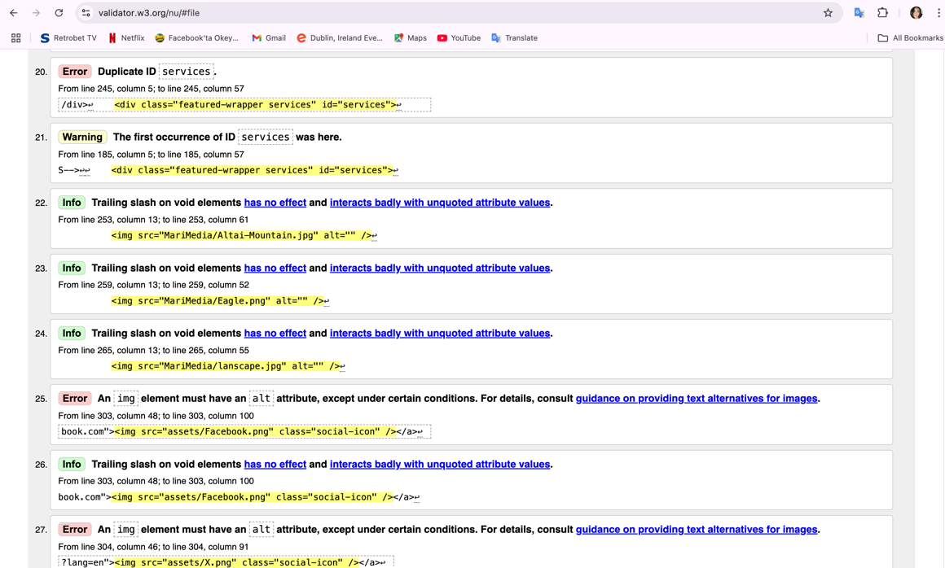

HTML Files: 2-anniversarryTour.html (9 errors)

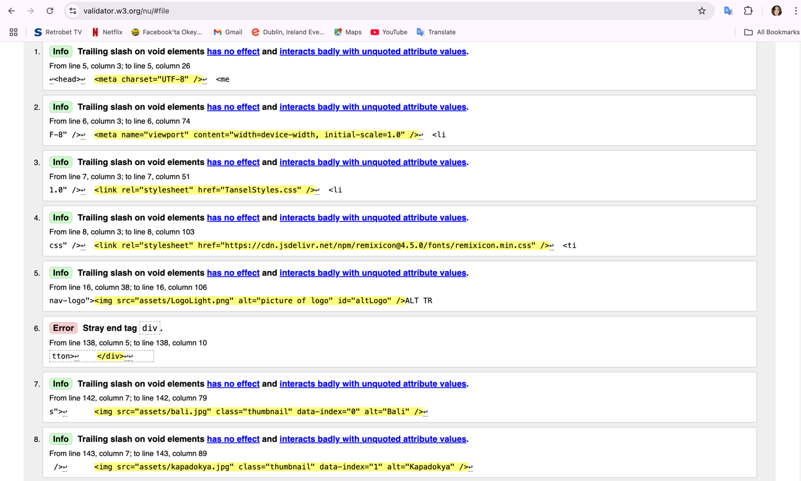

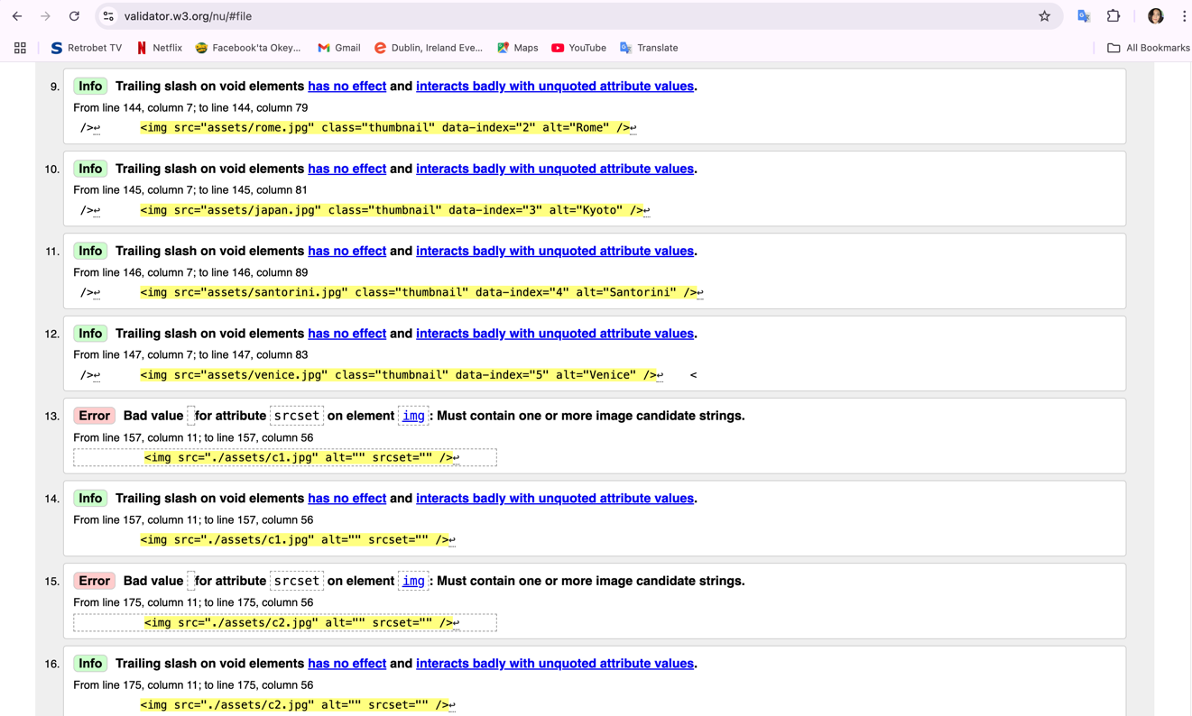

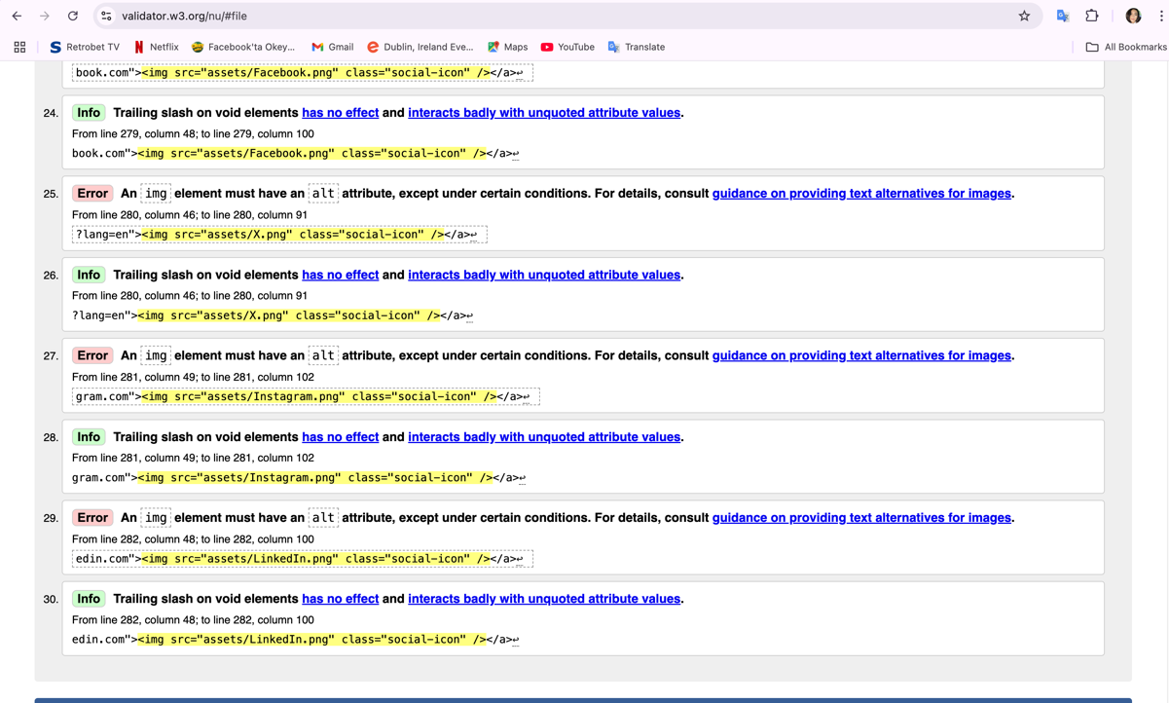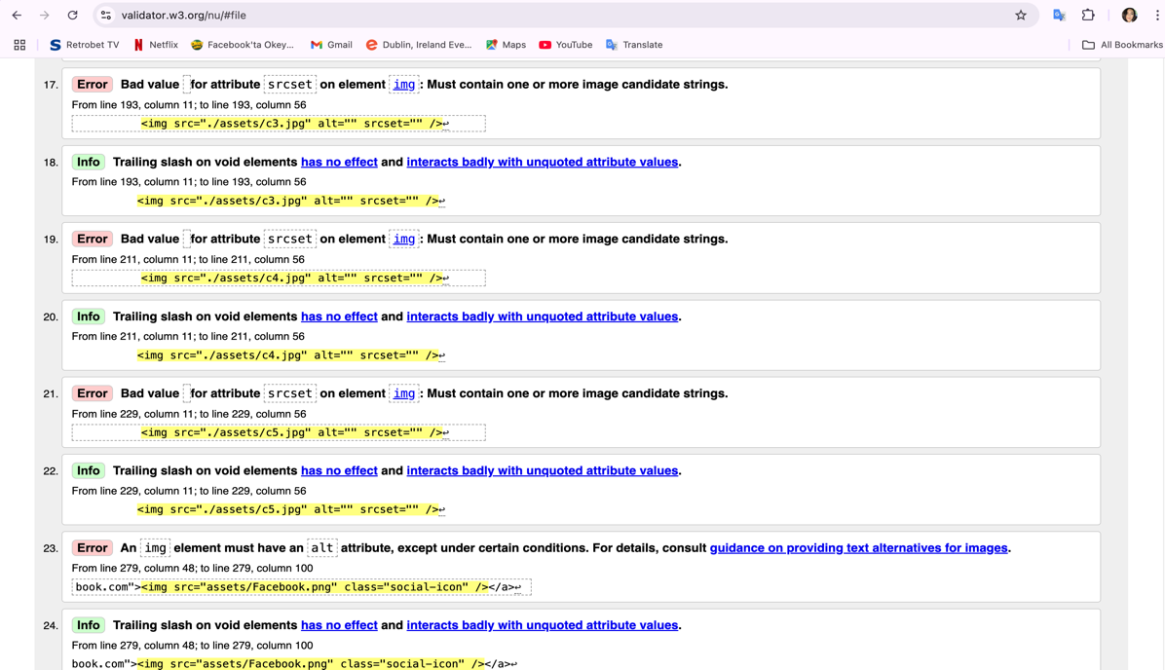

**1. Design**

Researched other 2 travel company’s pages>

www.paddywagontours.com

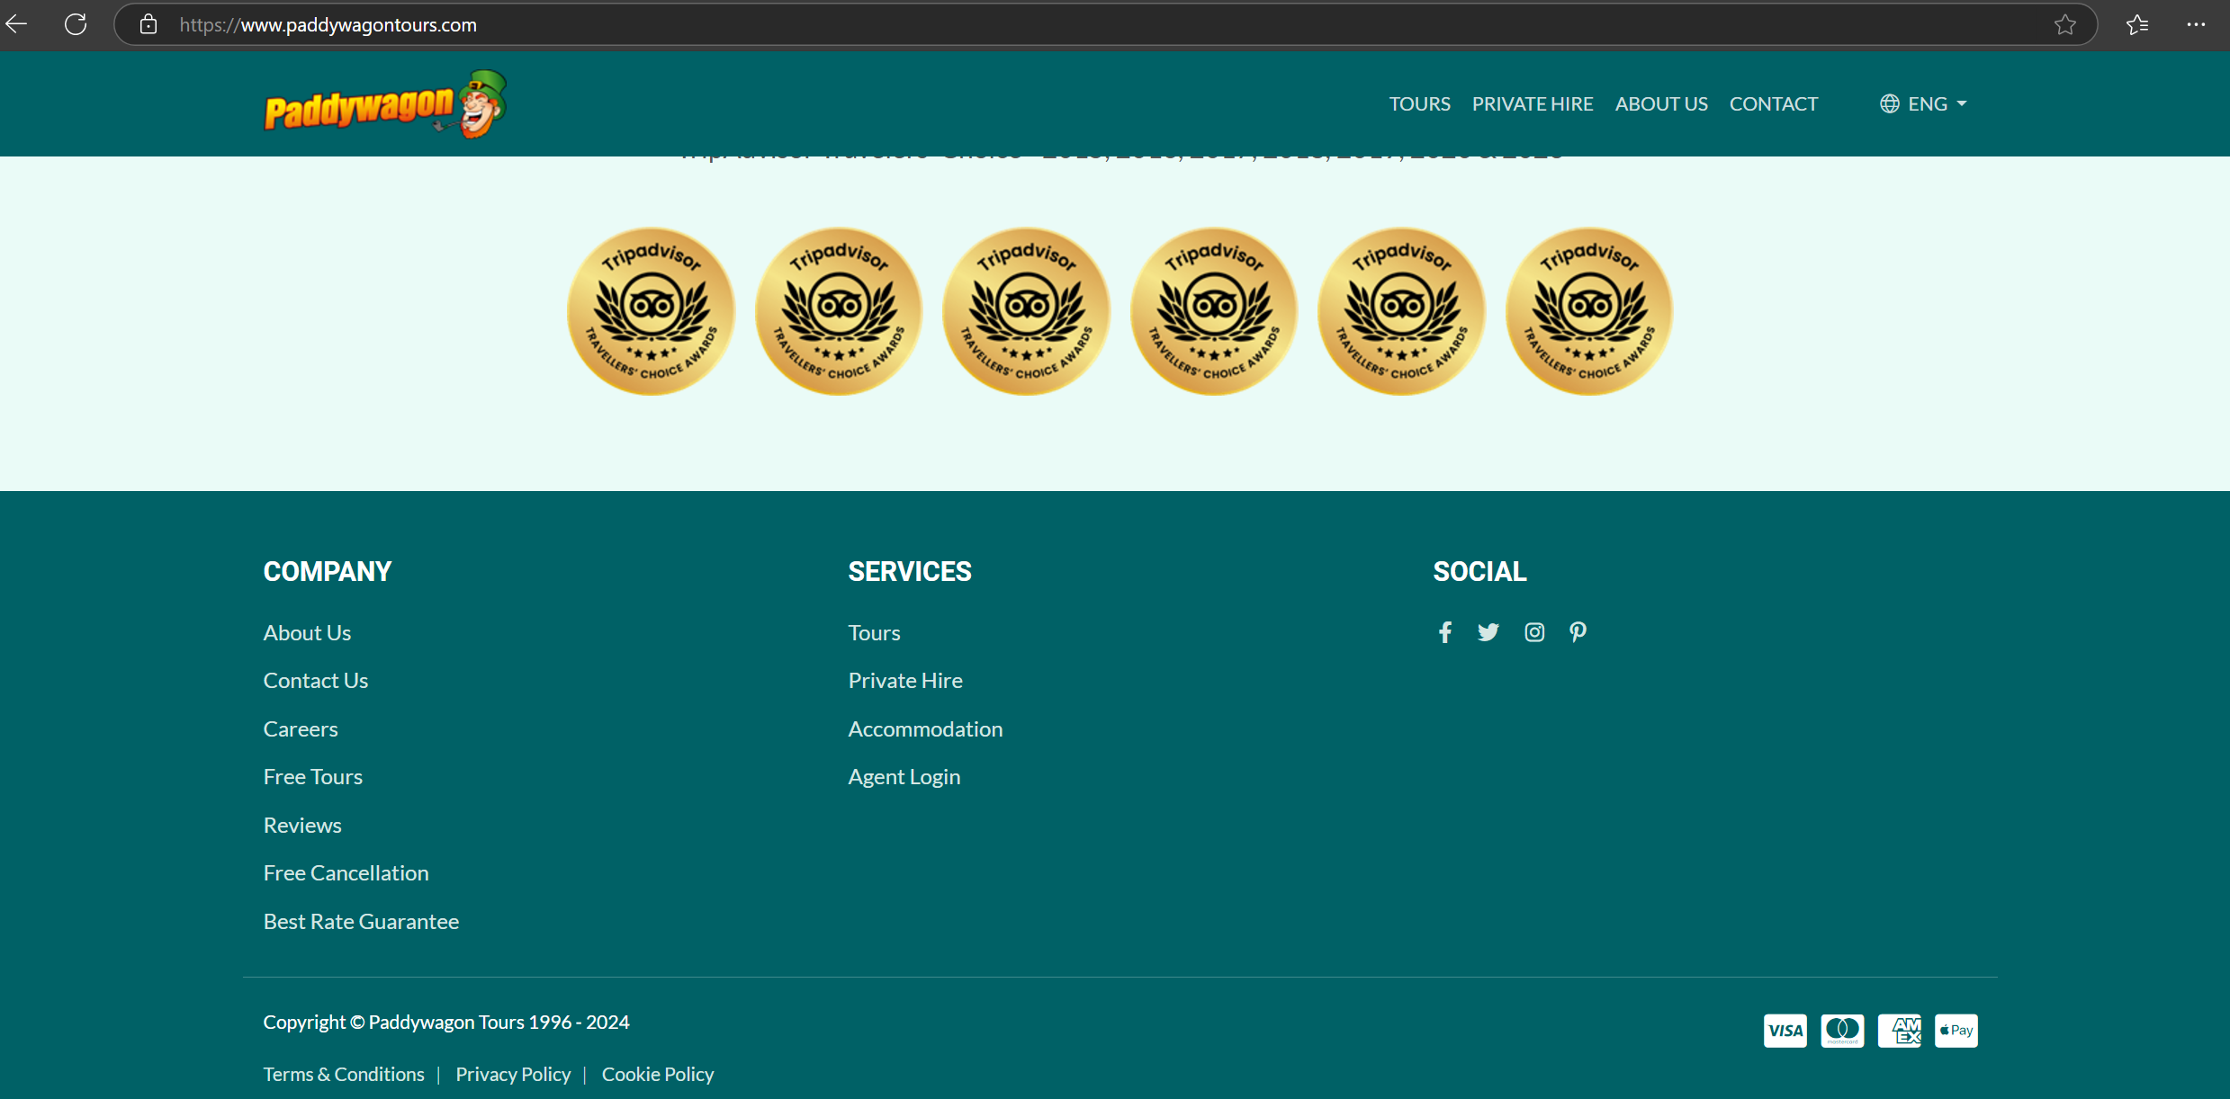

www.halsbury.com

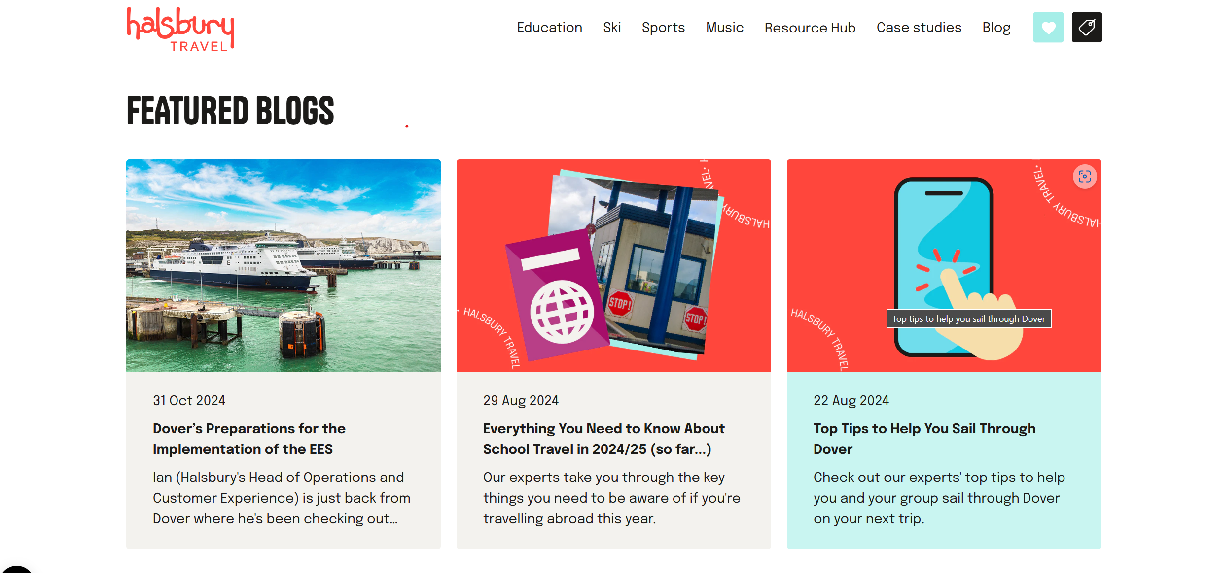

Design Color:

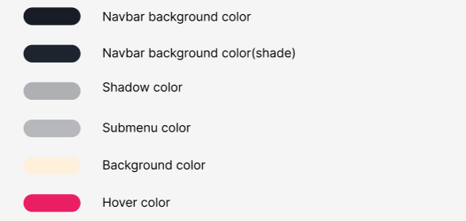

**2. Wireframe (Family Tour page , Contact page, MariPayment.html , MariPopUp.hmtl) / LKHAGVADULAM BOLDBAYAR /**

Family Tour Page/ Created by LKHAGVADULAM BOLDBAYAR/

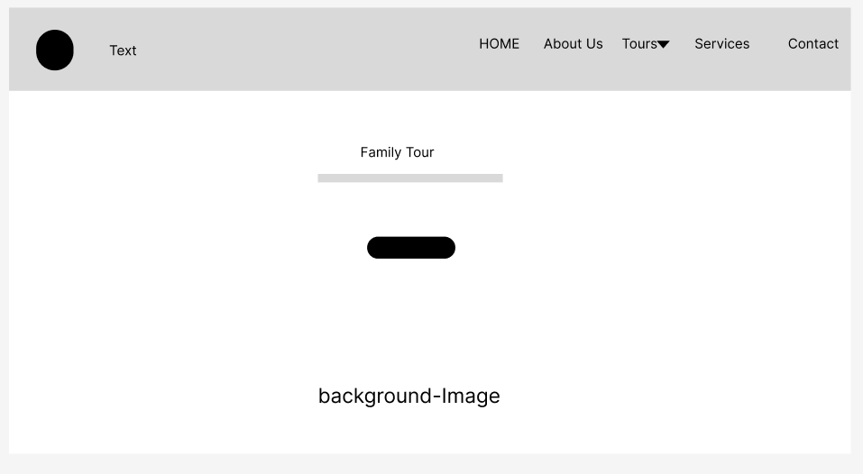

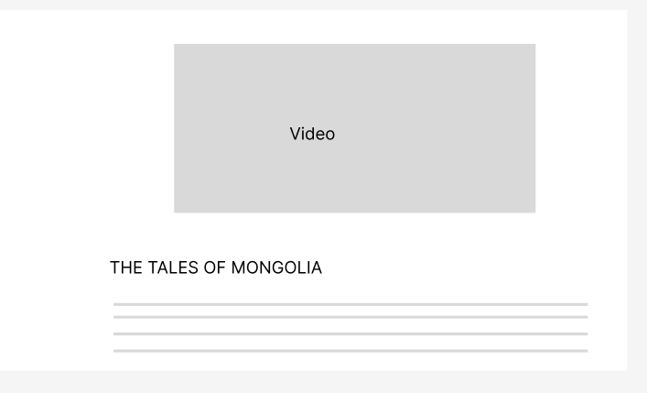

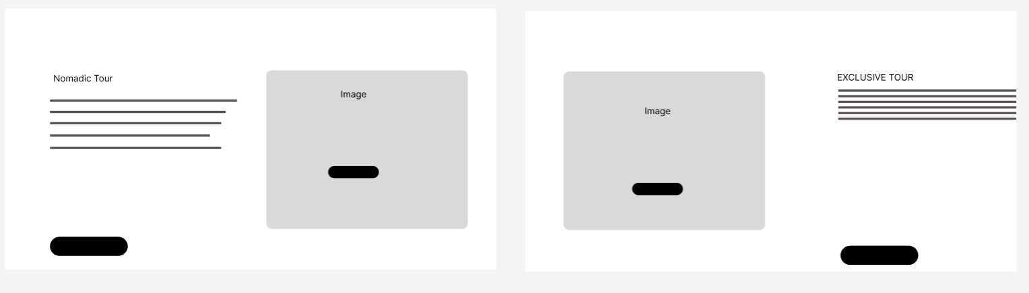

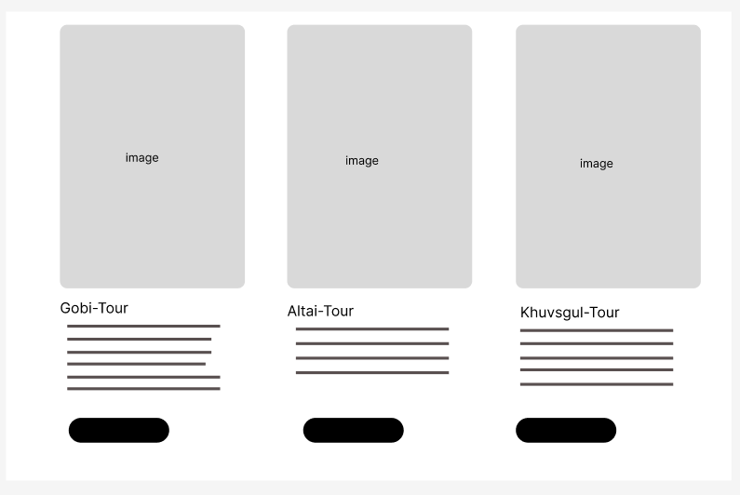

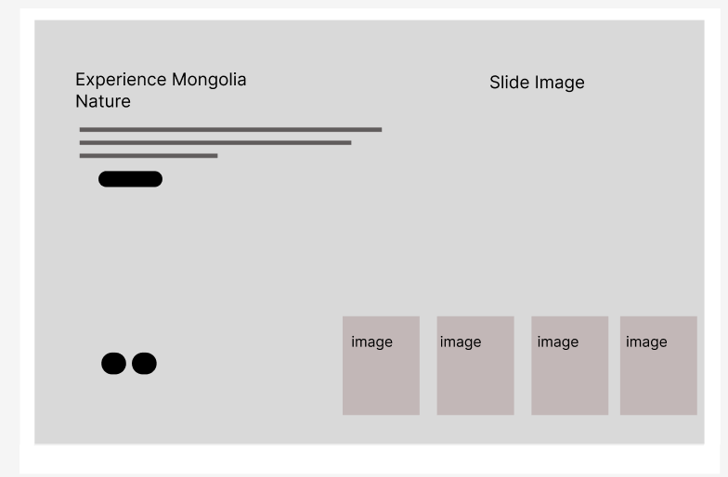

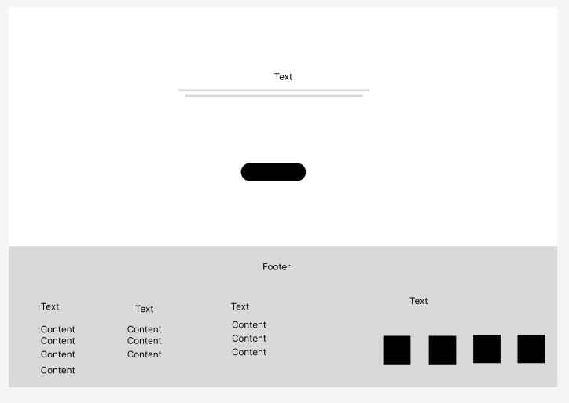

Contact Page/ Created by LKHAGVADULAM BOLDBAYAR/

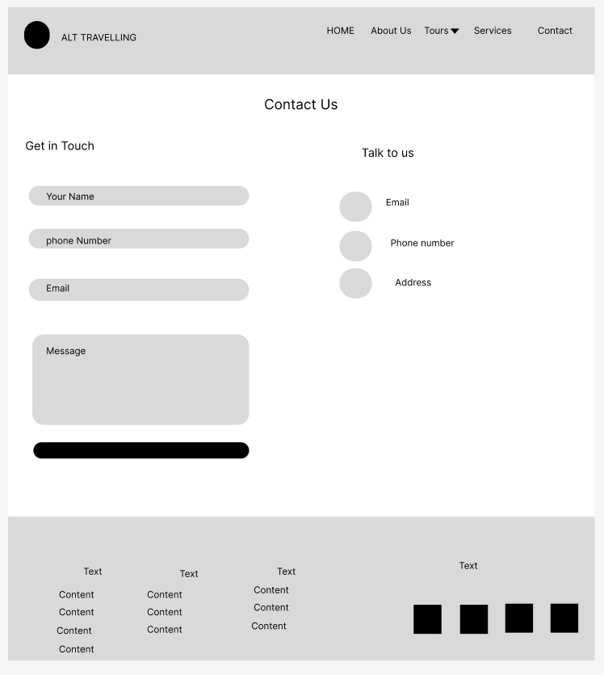

MariPayment.html and MariPopUp.html / Created by LKHAGVADULAM BOLDBAYAR/:

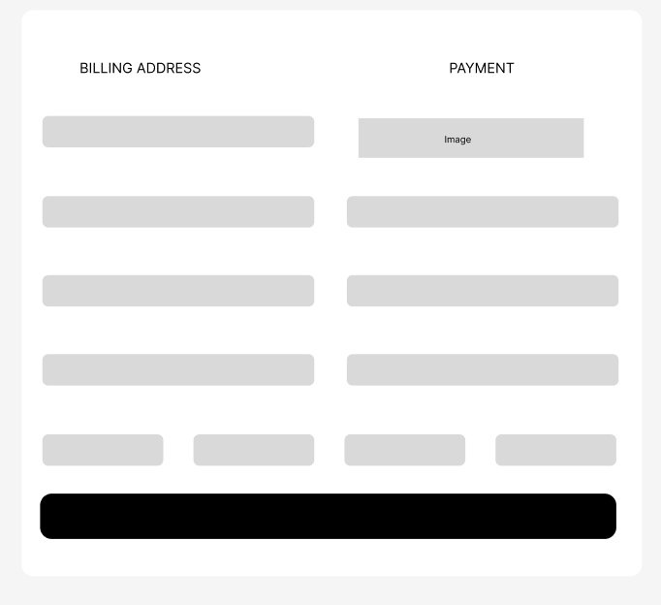 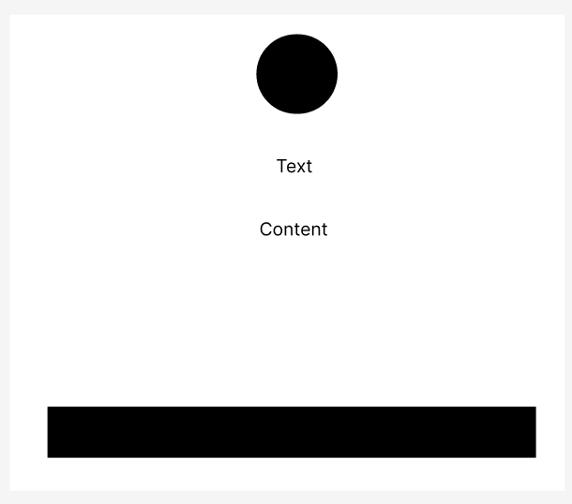

**3. JAVASCRIPT:**

**MariFamily.html Page Created: (LKHAGVADULAM BOLDBAYAR)**

MariFamily.html Page’s Smooth Scroll for <read more> button that is lead to video section that is (section id=”about1” in the MariFamily.html). href attribute contains the string #about1. The smooth scrolling effect applied when these links are clicked.

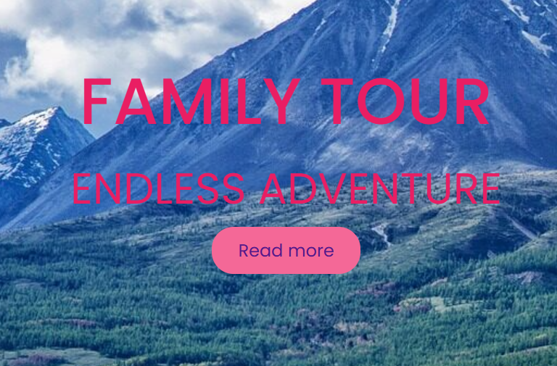 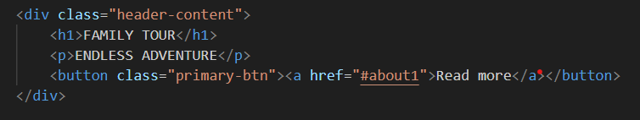

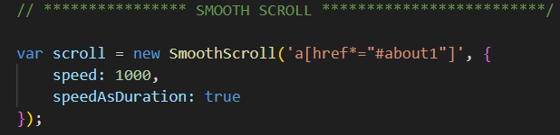

"When the payment button is clicked, it leads to the Payment Form page in the MariFamily.html section."

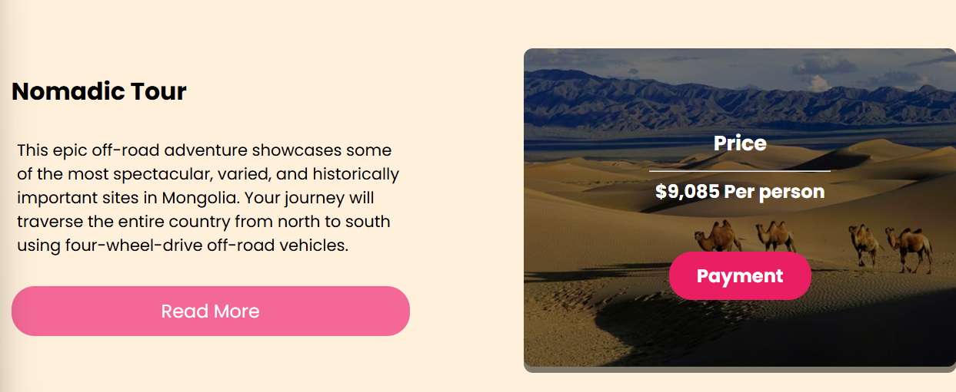

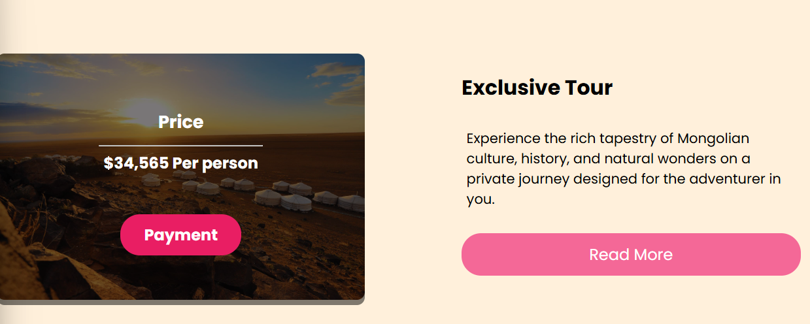

This is Payment Form is implemented using JavaScript. (MariPayment.html and PaymentJS.js)

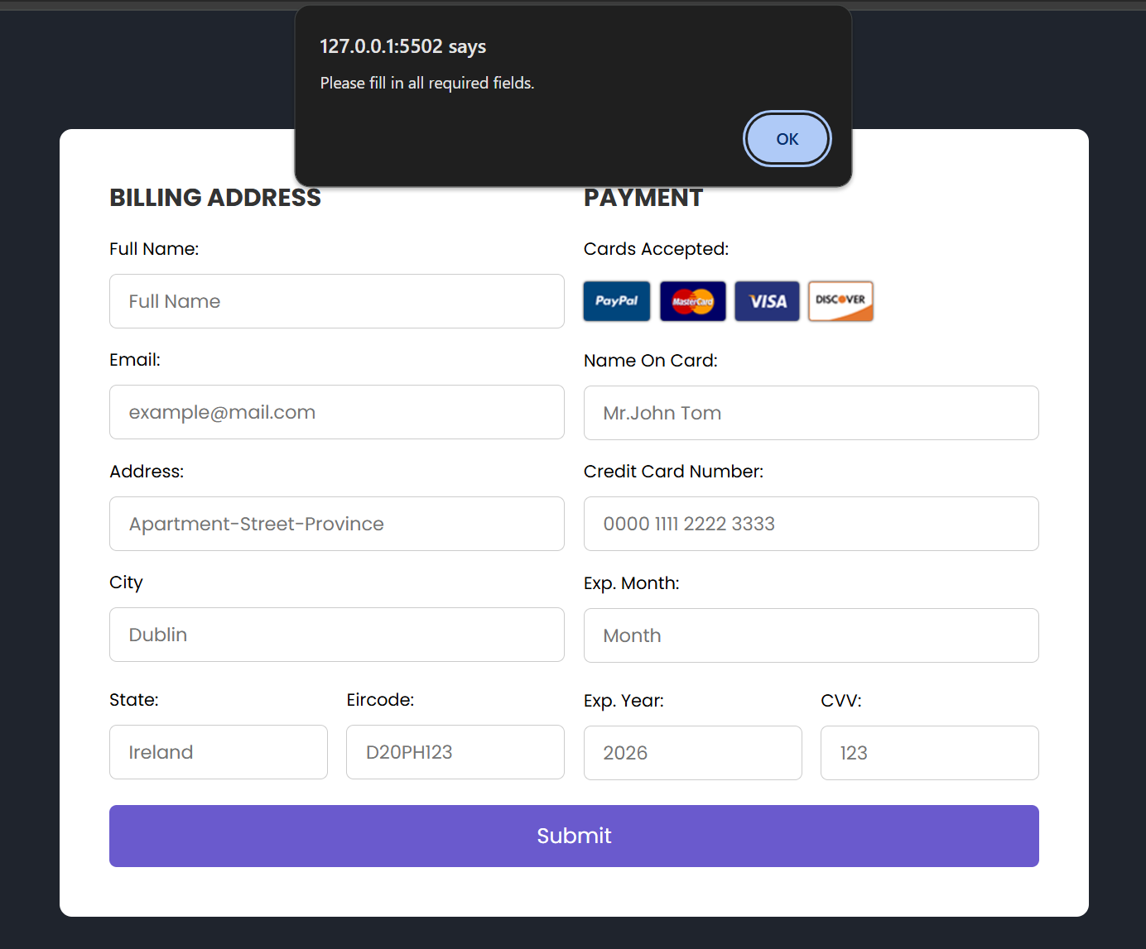 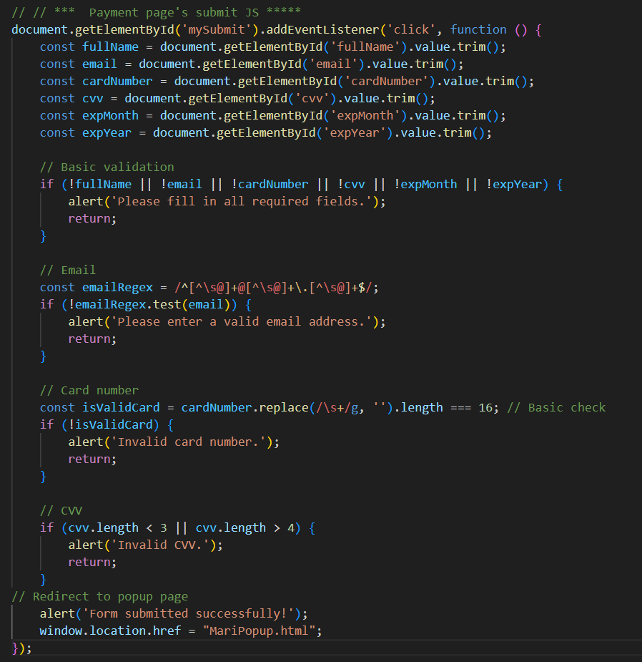

Payment Page's Submit Function

1. Event Listener for Submit Button:
   * The function is triggered when the user clicks the "Submit" button (with id="mySubmit").
   * The addEventListener ensures the function runs when the button is clicked.
2. Input Value:
   * Retrieves the values of input fields (fullName, email, cardNumber, cvv, expMonth, expYear) from the form and removes extra spaces using .trim().
3. Basic Validation:
   * Checks if all fields are filled:

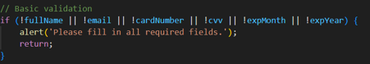

* + If any field is empty, an alert is shown, and the function exits (return).

1. Email Validation:
   * Uses a regular expression (emailRegex) to check if the entered email is valid:
     + A valid email must include an "@" symbol and a domain like .com.
   * If invalid, it shows an alert and exits.
2. Card Number Validation:
   * Credit card number contains exactly 16 digits (spaces are removed for validation):

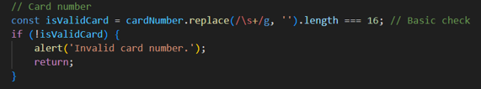

* + If invalid, it shows an alert and exits.

1. CVV Validation:
   * Checks if the CVV (Card Verification Value) is either 3 or 4 digits:

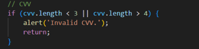

1. Successful Submission:
   * If all validations pass:
     + An alert says, "Form submitted successfully!".
     + Redirect to the "MariPopup.html" page.

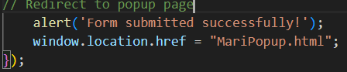

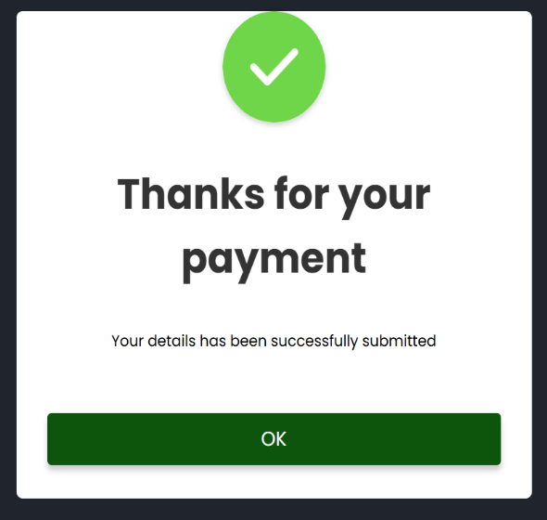When filled in all required fields and clicked Submit button which is lead to the below MariPopUp.html’s page. Also clicked the ok that is redirect to Our Home page.

**JavaScript: Read More 🡪 Read Less Button**

 🡪 

The hidden text becomes visible, and the button changes to say "Read Less."

If you click the button again, the text hides, and the button goes back to saying "Read More."

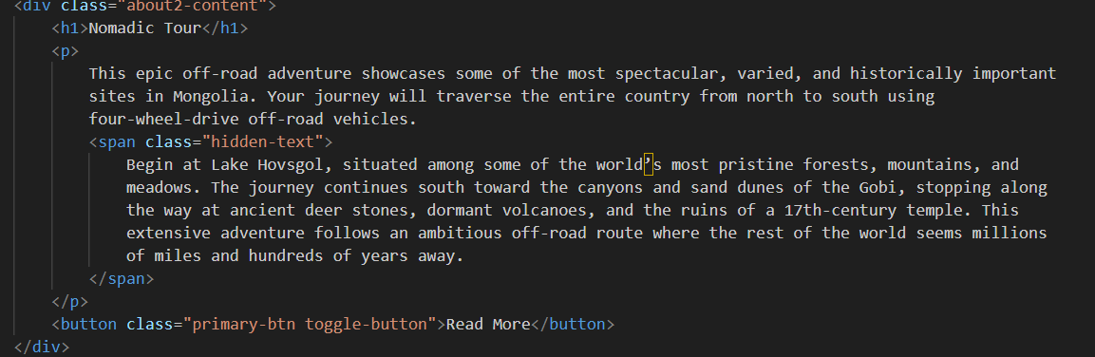

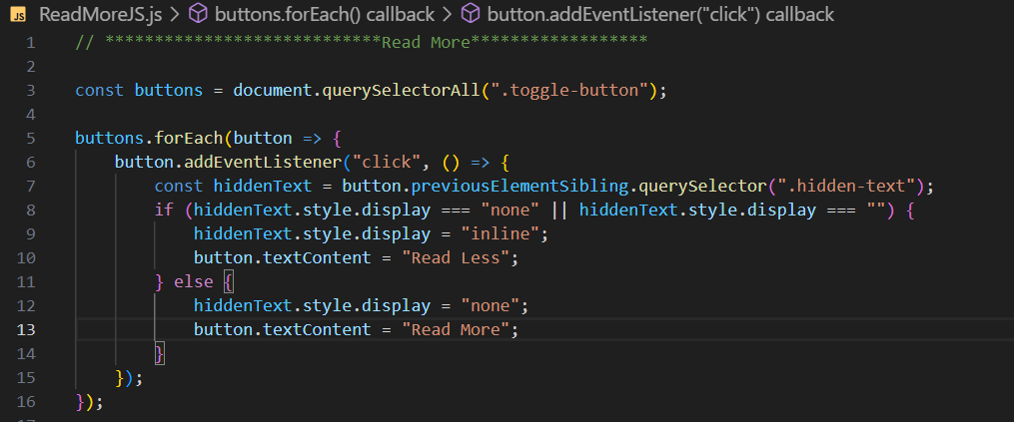

The Slide animation in the Images Section is implemented using **Javascript**.

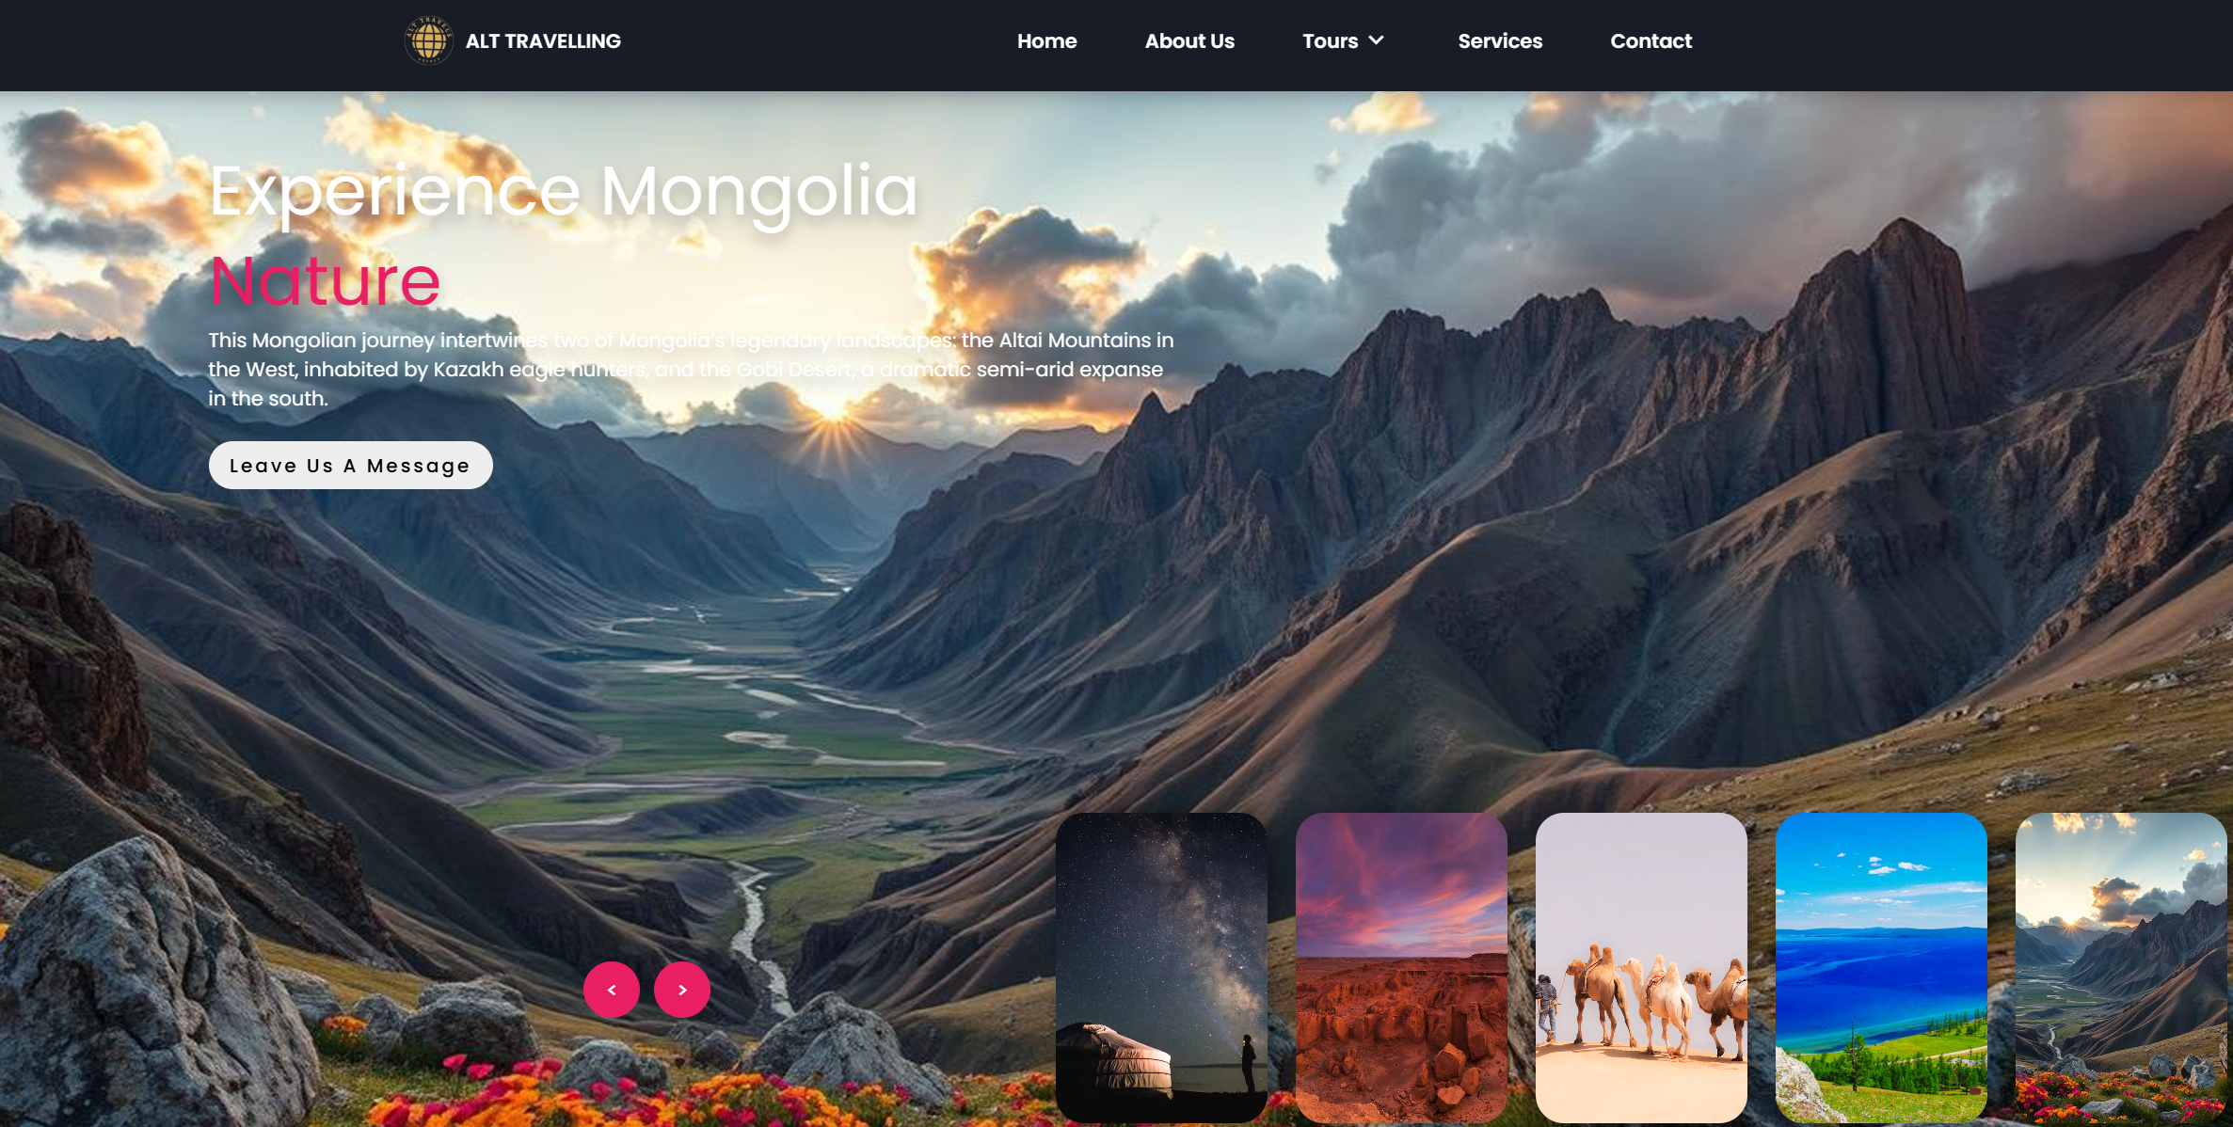

Part of example html code:

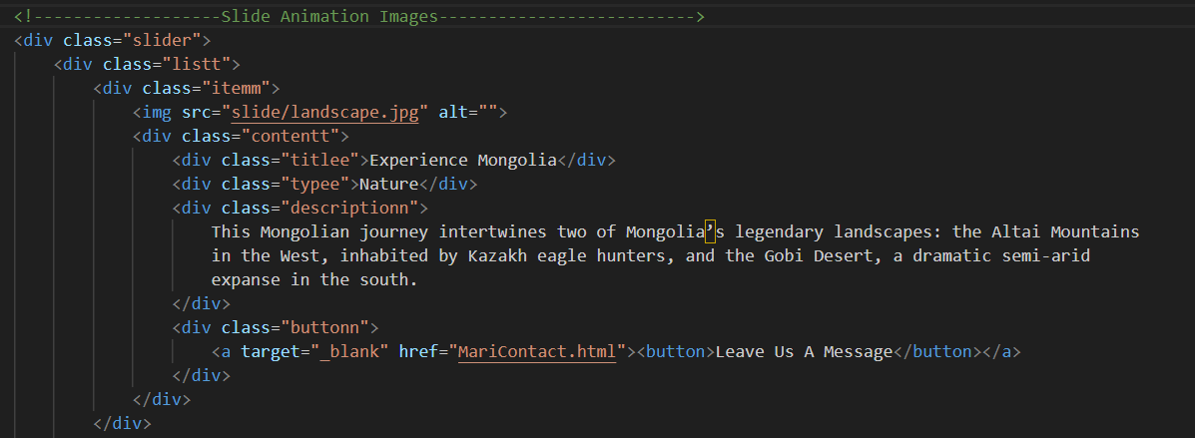

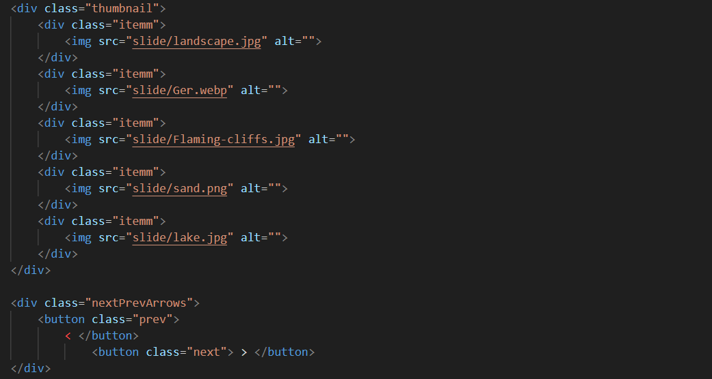

HTML Selection:

* “next” and “prev”: "Next" and "Previous" buttons for navigation.
* “slider”: The main container for the slider.
* “sliderListt”: The list of slider items inside the main container.
* “thumbnail”: A separate container for thumbnails (for smaller versions of the slider items).
* “thumbnailItemm” ’s: All items inside the thumbnail container.

Buttons:

* The "Next" button (nextBtn) triggers the moveSlider('next') function when clicked.
* The "Previous" button (prevBtn) triggers the moveSlider('prev') function when clicked.

Direction:

* Moves items in the slider and thumbnail containers based on the direction (next or prev).
* For next:
  + Moves the first slider and thumbnail item to the end of their respective containers (appendChild).
  + Adds a next class to the slider for animation.
* For prev:
  + Moves the last slider and thumbnail item to the beginning of their respective containers (prepend).
  + Adds a prev class to the slider for animation.

Animation:

* After the animation is complete (animationend event), the added next or prev class is removed.
* { once: true } option ensures the event listener runs only once for each animation.

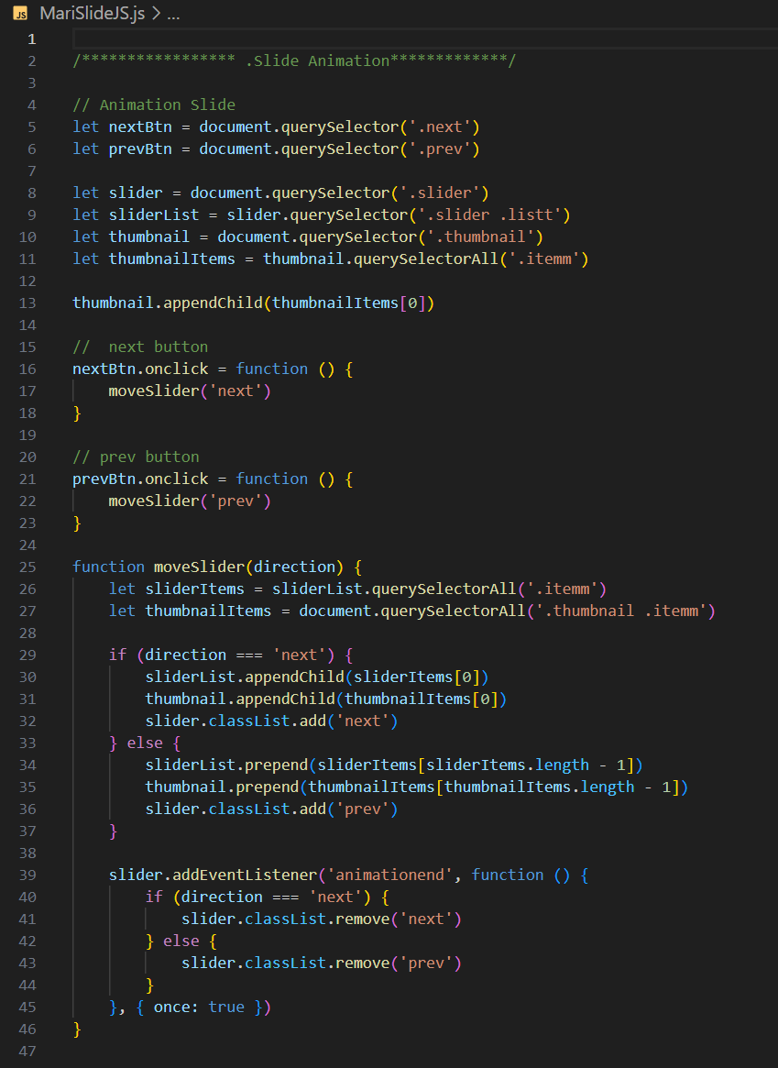

**Contact Us Page Created (LKHAGVADULAM BOLDBAYAR 23366141).**

"The contact form in MariContact.html page is implemented using **JavaScript**."

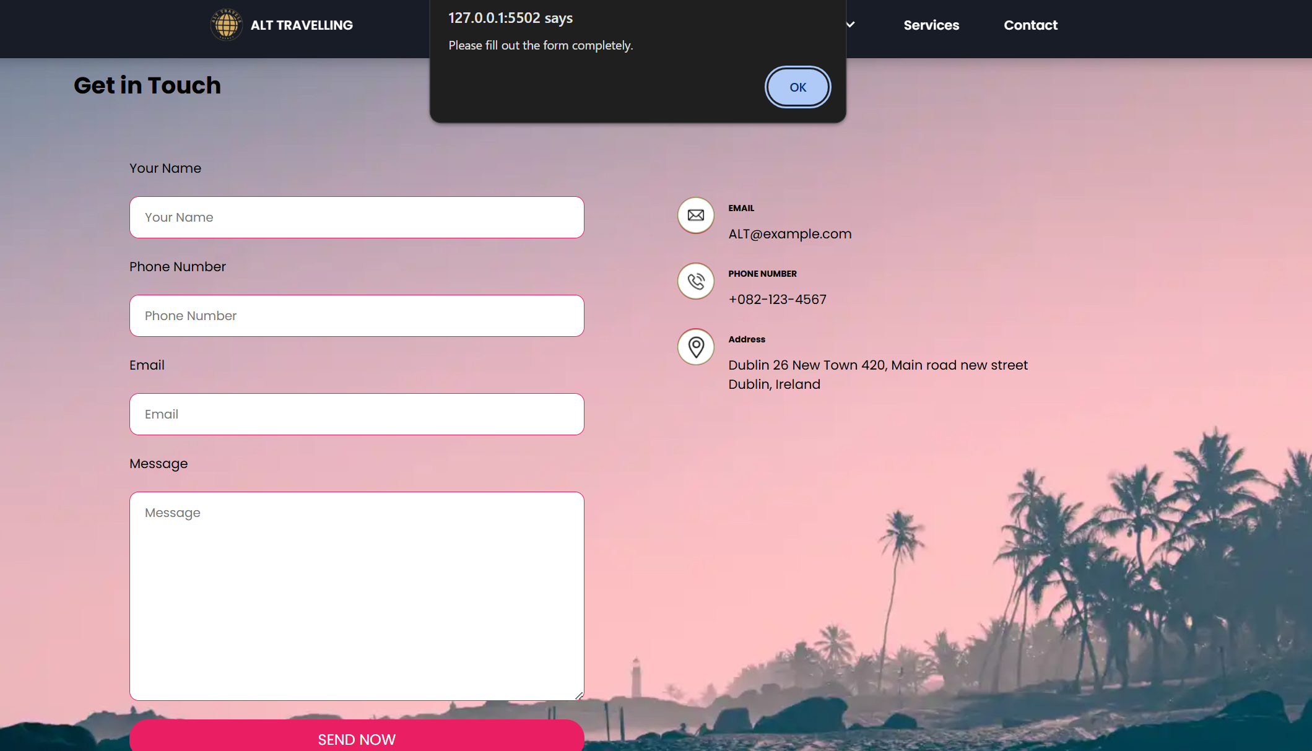 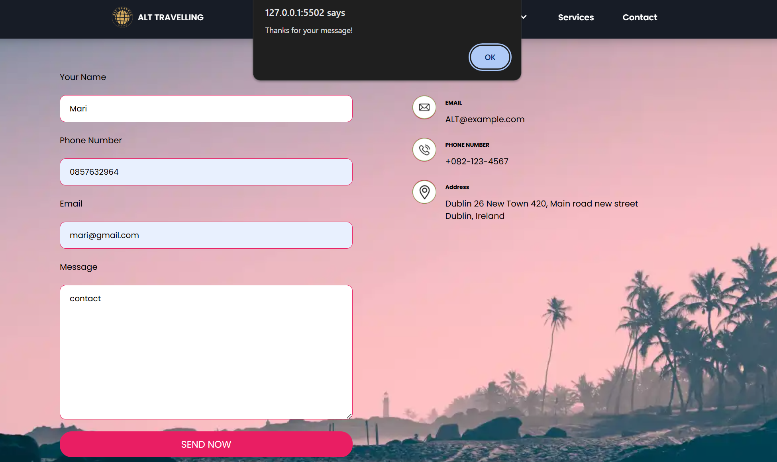

When clicked the OK button which is lead to Our Home page.

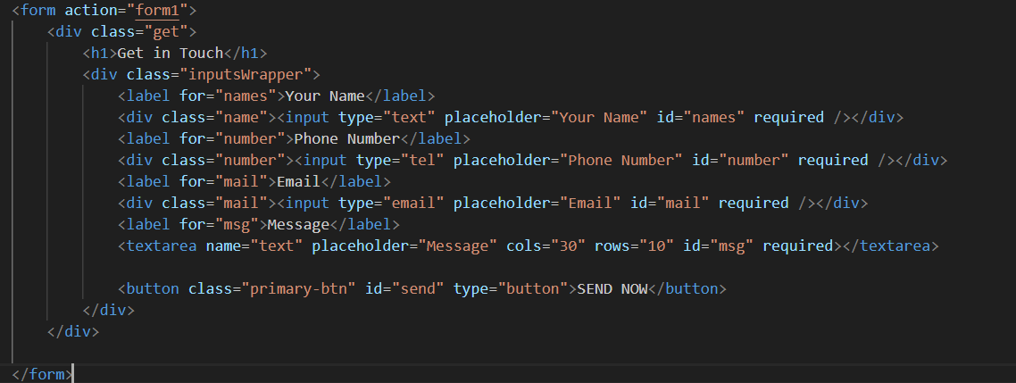



Used If statement with alert and window.location.href ;

 ensures that the getElementById(names, number,mail,msg,send). The onclick is attached correctly to the button id=”send”

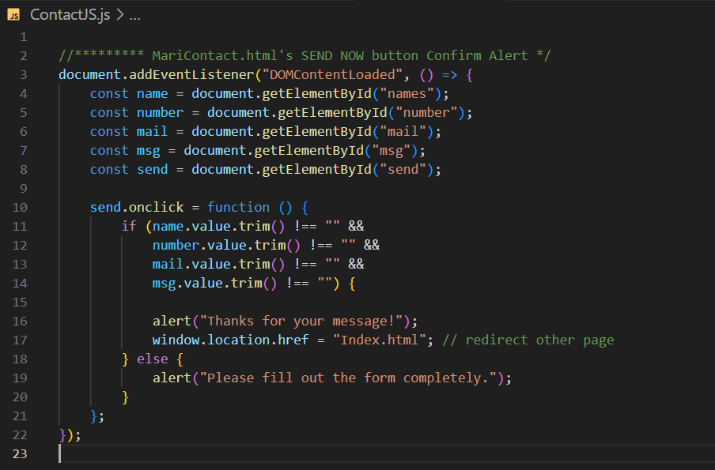

**JQUERY:**

"The overlay fading animation for the card images in the 'Our Family Popular Tours' section is implemented using **JQUERY**."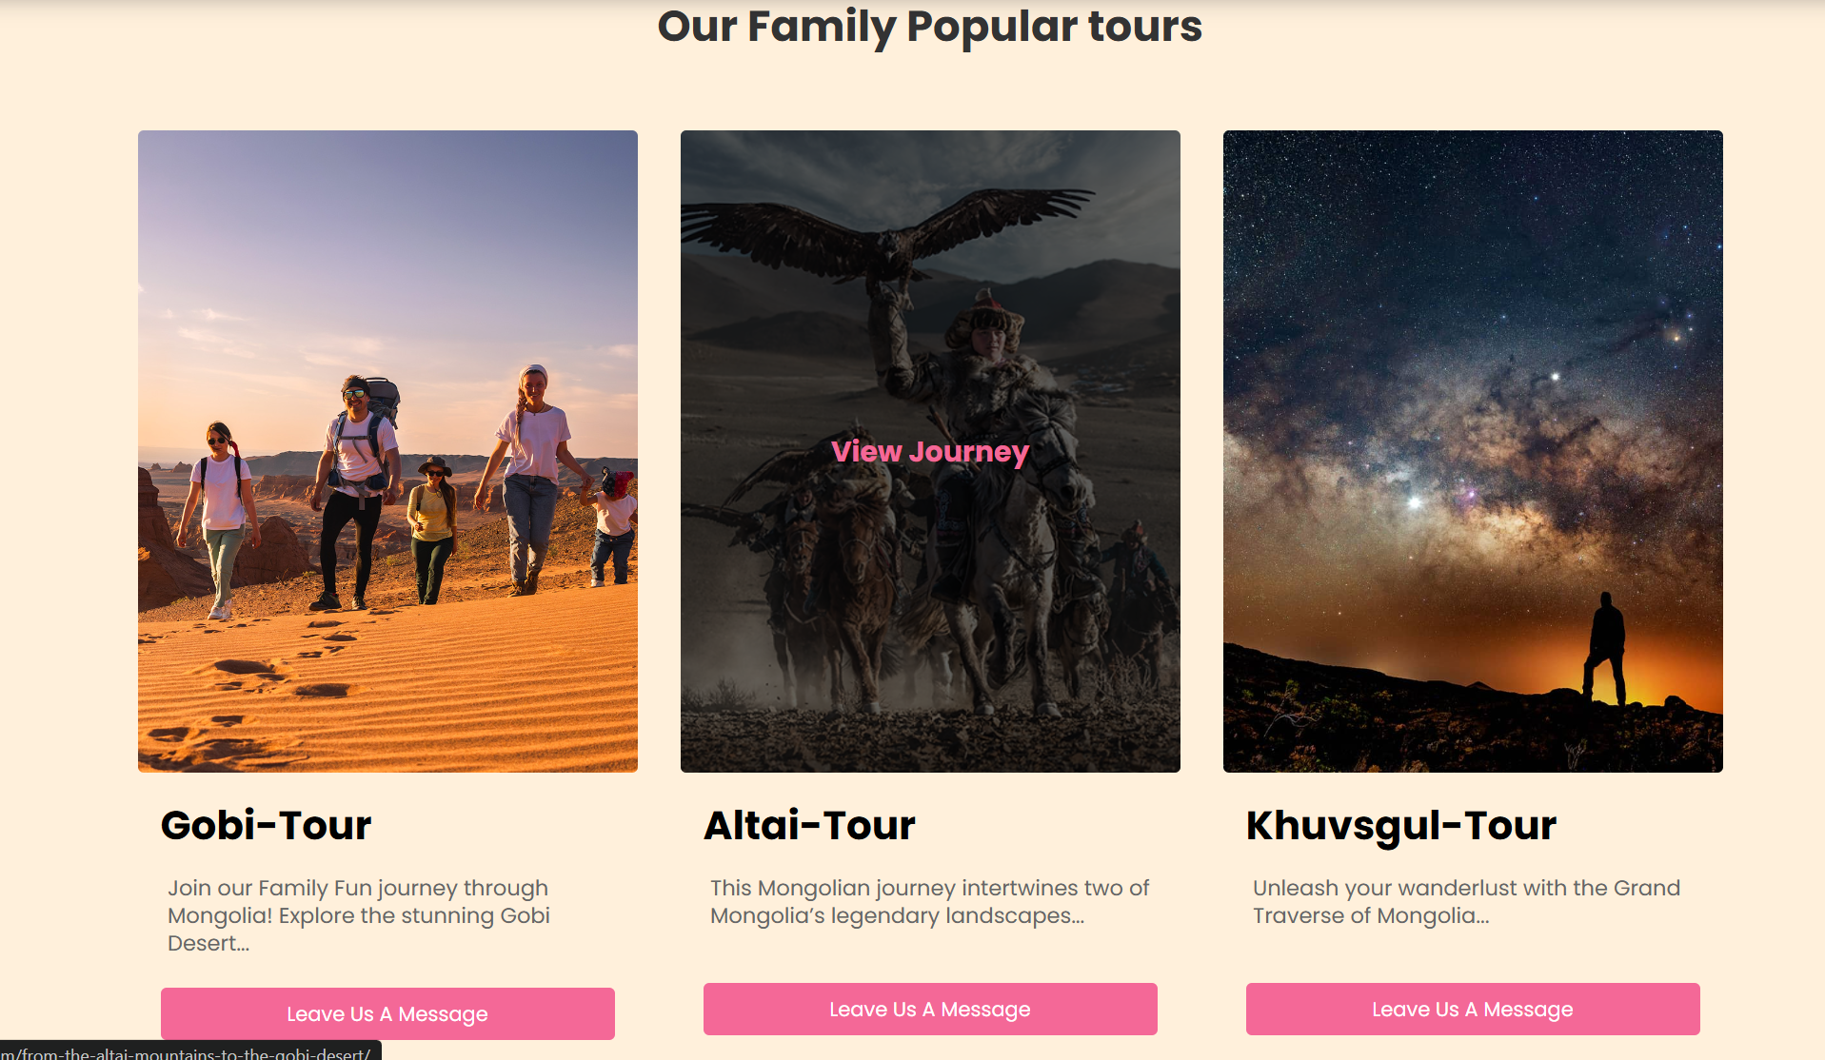

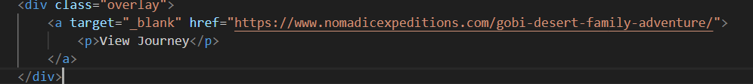

JQuery Syntax: $(), the shorthand for selecting elements $(‘.card’)

JQuery methods such as .hover(), .find(), .fadeIn(), .fadeOut()

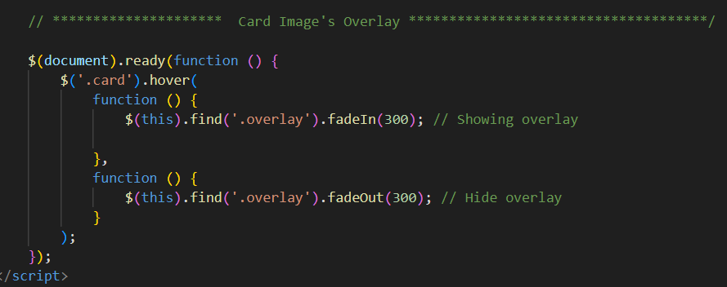

**4.VALIDATION: (Created LKHAGVADULAM BOLDBAYAR 23366141)**

**HTML Files**

**MariFamily.html (9 errors)**

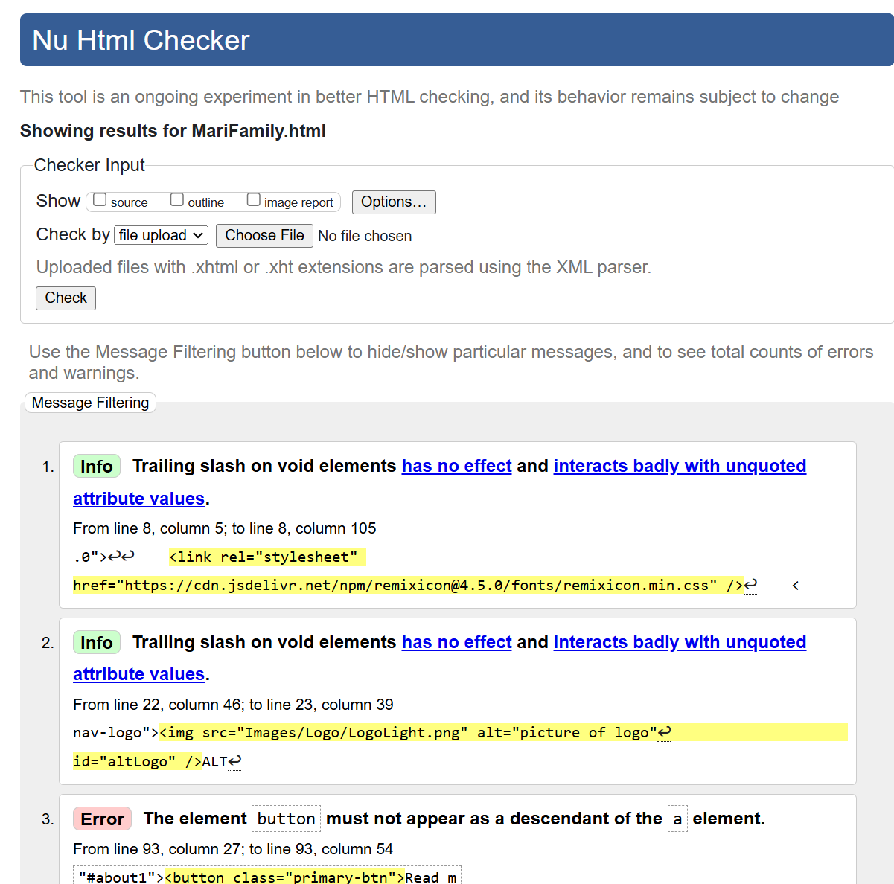 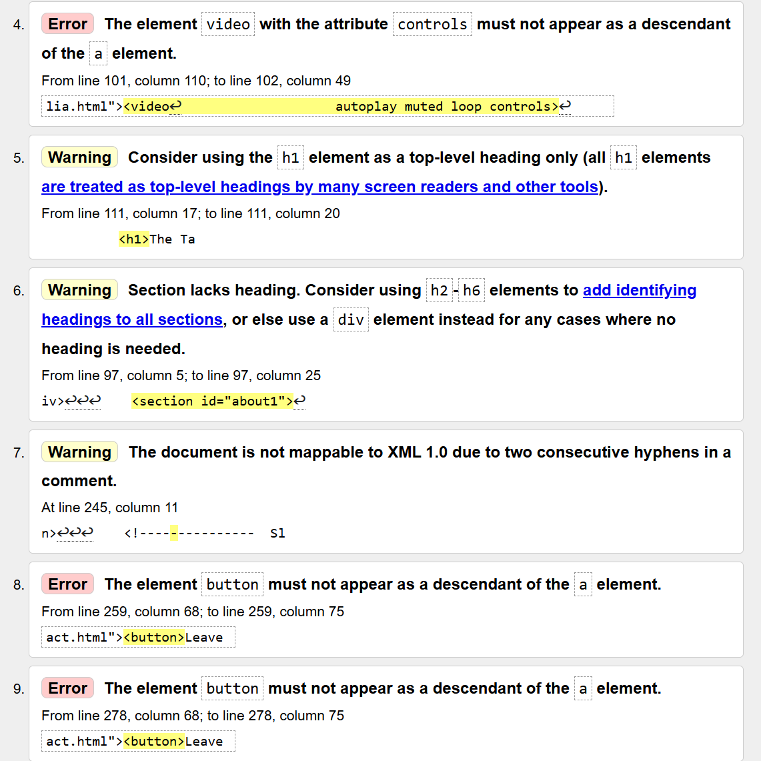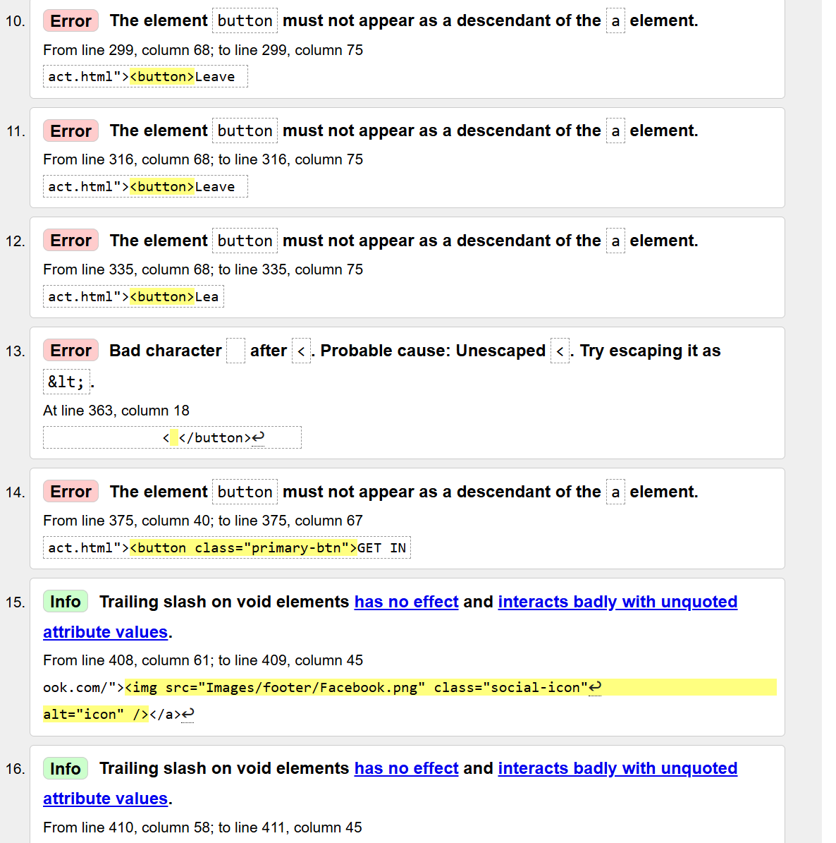

**MariContact.html (No errors):**

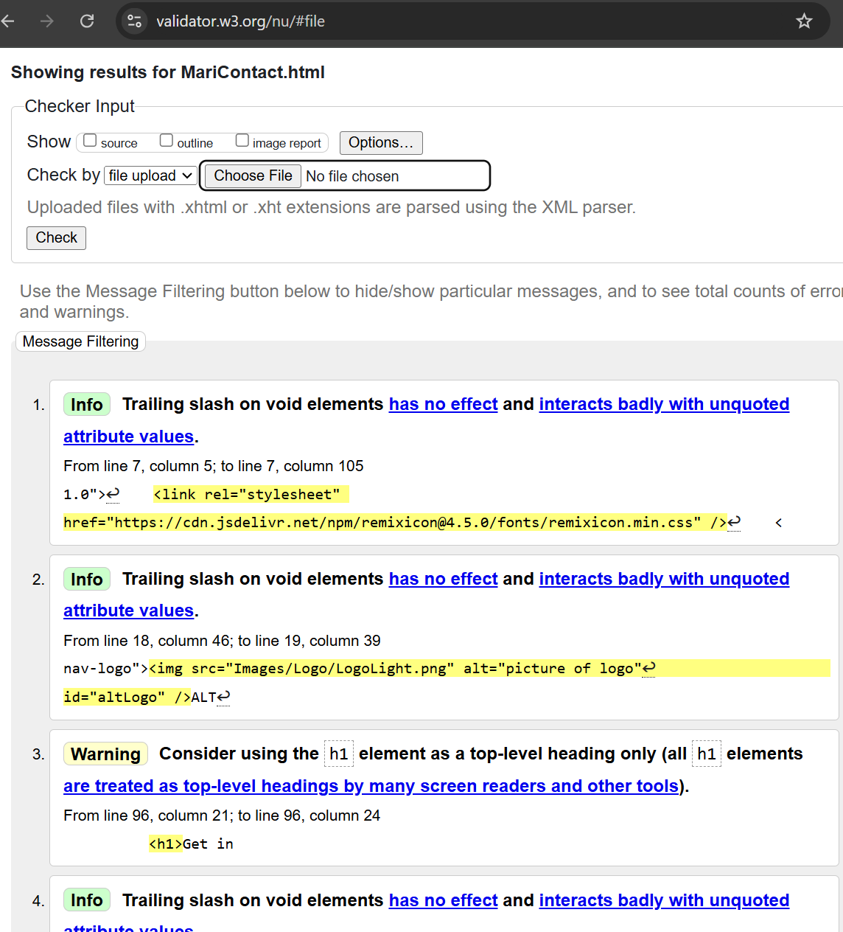

**MariPayment.html (No errors):**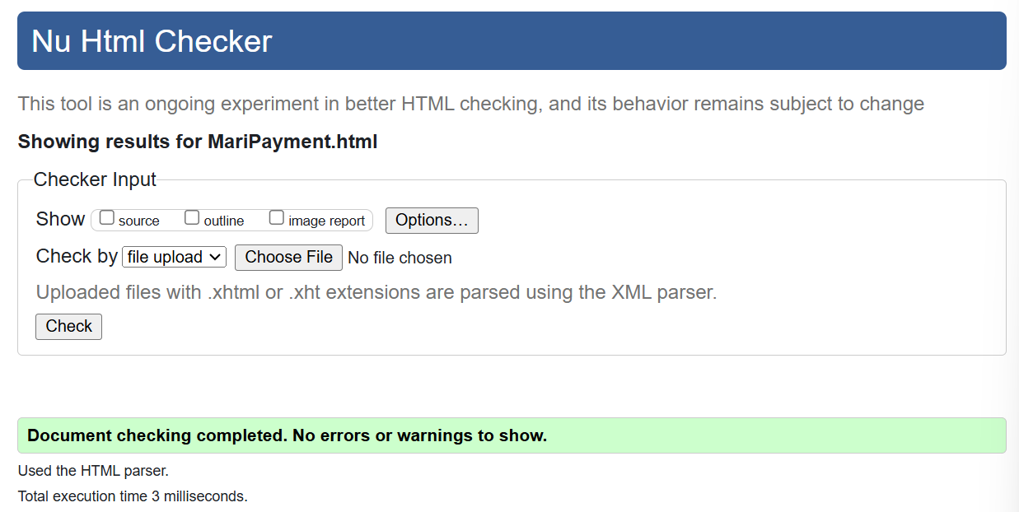

**MariPopUp.html(No error message):**

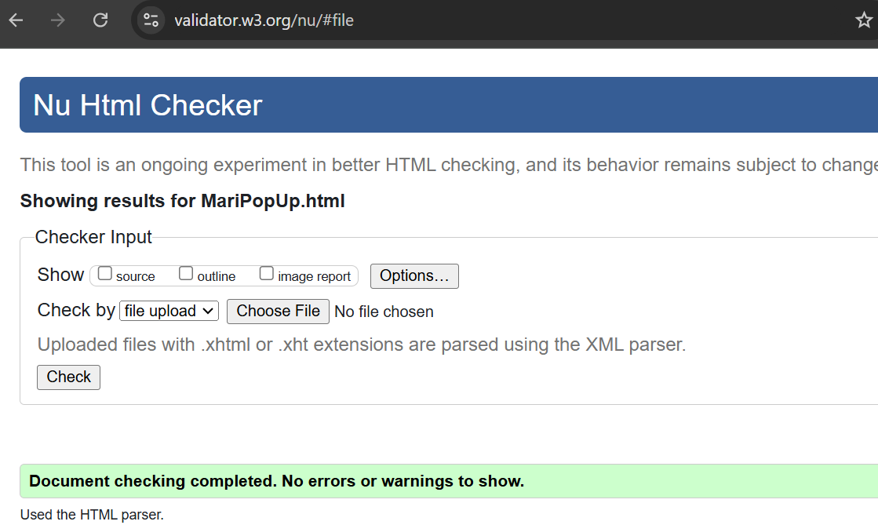

**Validation CSS File**

**MariStyle.css**

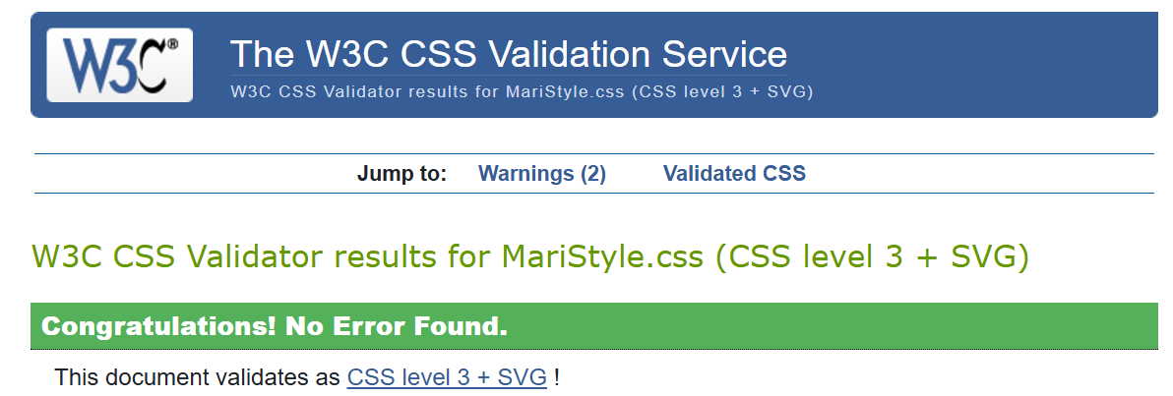

**7.REFERENCES**

1. <https://developer.mozilla.org/en-US/>

2. <https://www.w3schools.com/js/default.asp>

3. www.udemy.com

4. www.youtube.com

5. <https://github.com/>

6. <https://www.coursera.org/learn/html-and-css-in-depth/home/module/3>

7. <https://www.coursera.org/learn/getting-started-with-git-and-github/home/module/1>

8. <https://www.coursera.org/learn/programming-with-javascript/home/module/1>